Improving Coverage and Management Effectiveness
of Marine and Coastal Protected Areas

Socio-Economic Study
(MCPA) Karaburun-Sazani
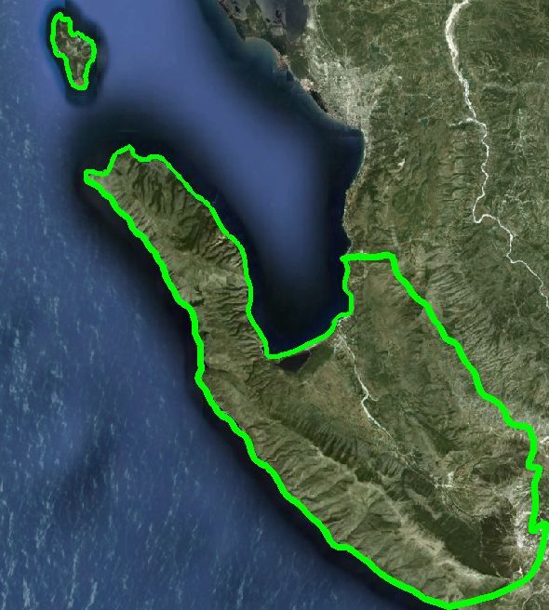

Reported by:

Madlina Puka
Socio-Economic Expert

December 2012

Table of Contents

- Introduction: Socio-economic expertise at Improving Coverage and Management Effectiveness of Marine and Coastal Protected Areas

2. Methodology
2.1 Field Methods
2.2 Study area

3 Socio-Economic Developments

3.1 Analysis of demographic processes and economic development
3.1.1 Population size, distribution and dynamics

3.2 Alternative livelihood development
3.2.1 Economy of the Area
3.2.2 Additional information on households` incomes

3.3 Social Assesment
3.3.a Social Participation
3.3 b. Distribution and access to knowledge

3.3.1 Education and social services
3.3.2 Health and Medical facilities
3.4 Settlement system and land use

3.4.2. Land-use patterns and trends
3.5 Cultural and Natural Heritage
3.5.1 Ethnography, handicrafts, spiritual culture

3.6. Infrastructure systems
3.6.1 Additional information for the ports within the study area and possibility of nautical tourism

4. List of references

5. Annexes

Abstract: This report presents an overall socio-economic picture on the characteristics of the Marine Coastal Protected Area (MCPA) Karaburun-Sazani. It looked at the local livelihood characteristicss, the current community patterns and usage of resources, governmental controlling mechanism and decision-making as well development planning and future perspectives of the area.
The study provides a summary of the actual baseline data and benchmark level and secondary to weight basic elements of analysis which will determine the priority actions that enable the protection and efficient coastal resource management of the mentioned target area.

Acknowledgements

During the completion of this work many people have been involved and need to be acknowledged.

First of all, I am very thankful to the Municipality of Orikum for its hospitality, the Portual Authoriy of Vlora as well as all the private enterpreneurs operating in the study area who cooperate to share their opinions with me.

In particular to all the municipal officers of the Departments of Agriculture, Forestry and Fishery, Urban Planning, Development Program Environment and Tourism, were willing to participate in the interviews and cooperate in the data collection.

- Introduction: Socio-economic expertise at Improving Coverage and Management Effectiveness of Marine and Coastal Protected Areas

This expertise on socio-economic sector will focus on development issues in the project area which relate to also successful management of the MCPA Karaburun-Sazani.

The main project outcomes relate to improved bio-geographical representation of marine and coastal protected areas (MCPA) and improved management arrangements for MCPAs, clarifying institutional settings and capacity building.

The overall aim is to secure the protection of Albania’s unique coastal and marine biodiversity for current and future generations.

The MCPA Project acknowledges that improved bio-geographical representation of marine and coastal protected areas project and improved management arrangements for MCPAs, clearly call for insight, knowledge and projections of socio-economic parameters, now and in the forthcoming period.

Thus, successful MCPA administration factors and, more importantly, their interaction with the social and economic revenue-generating mechanisms, setting-up and sustainable management of MCPA buffers zones, MCPA management and business planning, revenue sources, socio-economic characteristics and data on land use planning will be analyzed from an environmental standpoint, which should encapsulate a much wider area than the project area.

All these are associated with and must be diagnosed subject to today's demographic situations, migratory movements, structure of habitat and its relationship with different networks (potable water, health, electricity, roads) ethnological morphology, social setup, community patterns and services, water management, economic activities of exploitation of natural resources, tourist exploitation and recreational use of the area, planning and decision-making bodies - enforcement and control mechanisms, local, regional and national level development projects.
Understandably, all these efforts will contribute into other related project activities and challenges.

- Methodology

Referring to the ToRs (National Consultant for Socio-economic issue), the study report is responding to different questions like as listed below:
- Human activities and resources use in the area
    - Sociology and population
    - Land use and local economies including resource and land management
- Local development (Annual income of local residents, status and prospects of employment]; area planning instruments [planning and decision-making bodies, control mechanisms, building and urban planning regulatory mechanism: the impact on local level, regional, national and local development projects in urban planning, agriculture, tourism, infrastructure)

The study is based on the secondary data research and review, involving, collecting and analysing, a vast array of information based on the statement of the purpose developed in the ToRs.

The sources of secondary data used are: official statistics, local government documents, as well technical reports of several institution and research activities. The evaluation of the quality of the collected documents and the updated information is realised via field visits including interviews and meetings in the study area.

  - Field Methods

This study combines qualitative and quantitative methods, which together provide a richer base for analysis. Whereas quantitative data explains structures through figures and numbers and provides practical statistics that will be combined with other practicable actions which gives more insights into the context and helps understand the reasons behind the data.

Table 1 Assessment Methods
Phase | Method
Orientation: | Discussion, collection and analyzing secondary sources, observation, informal conversations
Contextual description | Formal open and semi-structured in-depth interviews with officials/enterpreneurs, key informants, discussions with local residents

2.2 Study Area

The national MCPA Karaburun-Sazani proclaimed in 2010 covers a marine area along the coastlines of Karaburun Peninsula and Sazan Island. The marine park area extends between Orikum Municipality and Commune Qender. This last, due to the fact that Sazan Island belogns to Qender Commune.

A completed broad study of the Municipality of Orikum is realized considering its coastal and terrestrial villages in order to encounter all the typical human activity associated with the MCPA. With regard to the Qender Commune, it refers only to Sazan Island which has no civil population and it is a military facility. More than half of the island's surrounding marine area is part of the National MCPA of Karaburun-Sazan.

Orikum Municipality is located 18 km from the city of Vlora. It is bordered to the north with Vlora Municipality, in the south by Himara Municipality, in the east by the Communs of Kote, Brataj and Vranisht. Its boundaries are defined by the western slope of the Çika mountain, the borders of National Park of Llogara, Dukat Valley, Karaburun Peninsula and Sazan Island/ Qender Commune.

Map 1.
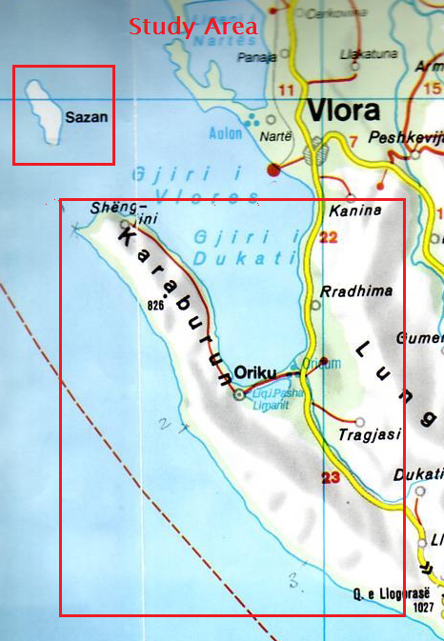

The Municipality consists of the town of Orikum and the villages: Dukat Fushë, Dukat, Tragjas and Radhimë.

Table 1. Distance between Orikum town and villages
Village areas | Distance (km)
Dukat Fshat | 11.6
Dukat i Ri | 6.7
Tragjas i Ri | 3.3
Tragjas i Vjeter | 5.4
Pashaliman | 4.7
Radhimë | 5.5

3.1 Analysis of demographic processes and economic development

3.1.1 Population size, distribution and dynamics

This section examines the population size and dynamics mainly for purposes of analyzing the present and future labor force availability in the area. The population data for Orikum Municipality are presented in the Table 2.1 and Table 2.2. The Municipality consists of Orikum town and the villages: Dukat Fushë, Dukat, Tragjas and Radhimë and the data are given specifically per each of them.
There are two sources of data for this table: Vlore Region Profile (2003), Orikum Municipality and the population study prepared by the Expert specifically for the project (2012).
In the study area, emigration rate is important and the emigration trend is reflected in the Vlore Region Profile (2003) which shows 32, 25% the migration rate for Vlore District.
In Orikum Municipality the resident population in 2001 is reported to be 6377 while the registered population in 2000 is quoted as 9735. The difference (34.5%) is attributed to temporary emigration. According to the Vlore Region Profile, the difference between the resident and the registered population for the whole area as shown above (assumed to be the level of migrant population) is 271, 086 implying a percentage of migrant population of around 41.2%.

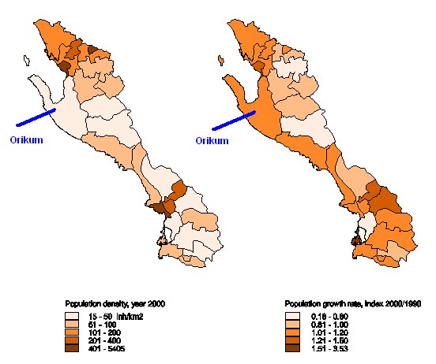

Table 2: Population data
Area | Vlore Region Profile  ( 2003) |  | The expert – MCPA project
 | Resident  (2001) | Registered  (2001) | 2001 | 2008 | 2011 | % Growth  (2001-2011)
Dukat Fshat | 6377 | 9735 | 1435 | 1648 | 1738 | 21.1
Dukat i Ri |  |  | 2715 | 3049 | 3196 | 17.7
Tragjas |  |  | 1140 | 1335 | 1381 | 21.1
Orikum |  |  | 3708 | 4395 | 4635 | 25.0
Radhimë |  |  | 737 | 954 | 1004 | 36.2
Total |  |  | 9735 | 11381 | 11954 | 22.8
Source: Vlore Profile (2003); MCPA- 2012, Registration Office of Orikum Municipality

Table 3. Demographic indicators for Orikum Municipality ( 2011)

Orikum Municipality | Population | Male | Female | Household | Size of  households
Orikum | 4635 | 2297 | 2338 | 2130 | 2.2
Radhimë | 1004 | 512 | 492 | 392 | 2.7
Tragjas | 1381 | 687 | 694 | 342 | 4
Dukat i Ri | 3196 | 1646 | 1550 | 693 | 4.6
Dukat Fshat | 1738 | 908 | 830 | 407 | 4.3
Total | 11954 | 6050 | 5904 | 3964 | 3
Source: Registration Office of Orikum Municipality

The following conclusions could be drawn as regards the population dynamics in the study area:
- All the villages shows a decrease in household size since 2001. The average size of households in 2001 is 3.98 member per family and the result shows that households nowadays are smaller with 2-3 people per household.
- The total population is increase app 27.8%. All the villages show an increase in household number, in particular coastal location i.e Radhima village even smaller than the other ones shows an significant increase in household and population number followed by Orikum town.
- Orikum town counts around 38,7% of the total population. Dukat i Ri (New) continues to be the biggest village and all these years is caracterized with arrival of new inhabitants.
- The issue which remains to be discussed, however, is the permanent resident population of the area being the base for the available labor force and from the point of view of numbers for supporting the Orikum`s priority sectors of local economic development. (Note: INSTAT has published the preliminary results of Census 2011for the Albanian districts but still not available the information for each local units/Instat Vlora)

3.2 Alternative livelihood development

3.2.1 Economy of the Area

This section provides a brief analysis of the economy of the study area aiming to provide a broad understanding of the present structure of the economy (together with its production and consumption patterns).

The Development Plan of Orikum Municipality has the objective of promoting sustainable economy that will take fully into consideration its natural and cultural resources. The economy of the area is reflected in what it produces. In the following, it is provided information what the area produces, how, and for which market. There are reliable local-level statistics pertaining to the study area as such, and the aggregate figures are updated recently.
For the purpose of this analysis, few figures will be used obtained through interviews conducted during the field visit to the area.

The economy of the study area may be described as “twofold”. There is urban economy with a large construction and service sector in Orikum and the northern part of the area (Radhima) and predominantly rural economy in the terrestrial villages.

Referring above, the dynamic sectors are mainly five: a) construction and services; b) livestock; c) agriculture; and d) the fishing sector.

a) Construction and services (tourism and other trade activities: see in the following): In Orikum are counted 280 enterprises, from which 40 of them are considered medium enterprise (Registered as shpk /Ltd as per Albanian legislation). The majority are concentrated in Orikum, Radhime and Dukat. The total numbers of registered tourism facilities and accommodation structures is 29 in total.

b) Livestock: Due to its alpine and subalpine pastures and meadows, the study area used to have and is developing now the livestock as the most important economic activity, especially goats and sheep. The livestock sector is the most important in the Municipality of Orikum. Dukat area is listed as the first area in Vlora region for its greatest number of sheep and goats heads.
This sector employs a considerable number of persons. Geographical position, the terrain and local tradition has made ​​the productive animal numbers be increasing. This growing development of livestock has come as a result the increased demand for livestock products and greater consumption of meat. In this area grow cattle, cows, goats, chickens, turkeys, horses, pigs and bees.
The used area for sheeps are: Ravenna (in the Karaburun area), Tragjas-Orikum valley, Dukat field, ​​Valtos area (former lagoon area) and partly Radhima. The goats grazing in the mountain range from Dhermiu in Gjuhez (Karaburun Channel Area). Very few goats are kept within the villages, especially in Old Dukat.
As seen in the chart below Dukat field has the biggest number of cows and sheeps while Dukat Village has the largest number of goats and pigs.

The winter pastures of Karaburun Peninsula are used by Dukati sheppers which each of them owned from 500- 1200 head of cattle ( sheep and goat). In total, there are around 20 sheepfolds (corral) in Karaburun Peninsula. During summer time, they move toward Dukati valley.

Some of the main problems facing livestock sector in the area is about variety improvement of cattles, improved feeding structure, the creation of adequate sanitary conditions, etc.

The area is known for its considerable production of milk. According to the records kept from local dairies ( Dukat area) as well statistics of Orikum Municipality the milk and other productions for 2011 was as follows:
1. Cows: 3,099,600 l milk
2. Sheep: 1,029,000 l milk
3. Goats: 800,550 l of milk
4. Poultry: 2,860,000 eggs
As a result of the milk production in the territory of the Municipality, there are 4 dairy factories, which provide qualitative dairy products.

In the following is given a general picture of the livestock in the study area making a comparison for the period 2003-2011.

Tab. 4.1 Livestock progress - Cattle status

Tab. 4.2 Livestock progress – Sheep’s status

Tab. 4.3 Livestock progress – Goat`s status

Tab. 4.4 Livestock progress – (chicken, horses, honey etc)

c) Agriculture:

The major agricultural land is composed of Dukat Field, Tragjas terrain and Orikum which are formed by Dukat river sediments. Tragjasi area and some parts of Orikum land are classified as good quality and productive land, suitable for various agricultural crops. The area is characterized by the cultivitation of grape, citrus and olives.
According to the statistics of the Municipality, the surfaces planted with the above varieties are given as below:

Tab 4.5
Nr | Variety | Surface (hectar) | Note
1 | Viticulture (vitis viniferasp, San giovese, merlot) | 80 | Growing trend is 10% increase of the total surface per year
2 | Olive (Kalinjot, Frantoio) | 100 | Growing trend is 20 ha increase per year
3 | Citrus (tangerine, orange, lemon) | 20 | Growing trend is 1000 plants increase per year

As well, the climate condition are favorable for the cultivation of fruits and vegetables. Its is worthy to make evident such varieties as: figs, plums, peaches, persimmon, almonds, pomegranates, and vegetables, especially watermelon, potato, melon, tomato, leek, onion, of high quality production.

The production of the economy of the study area is largely consumed by the local market. The producers in fact are facing difficulties with the food processing possibilities and an organized market place. However, the tourism is the obvious sector which should be relied upon to create market demand for agriculture and livestock.

d) Fishing and acquaculture:
- Fishing in the Orikum lagoon and the concerns of the fishermen:
The surface of Orikum Lagoon normally is 105 Ha and that goes 115 Ha when the level of the water of the lagoon is higher due to the weather conditions. The average depth of the lagoon is between 2.8 to 3.0 m.

Since on 2003, the lagoon is under the management of a private enterprise titled “Kthesa” that is licensed for exploiting its resources and is responsible for the lagoon maintenance. The enterprise is operating with 2-3 small boats called “sandals type” with sizes 3.8 – 4.0 ml long.

The number of the fishermen that operates into Lagoon under the management of “Kthesa” is nine in total. “ Kthesa” enterprise has established rules in order to protect the lagoon. Based on its rules, during February – May, the fishing in the lagoon is not allowed, the inlet called “Dajlan” and other communicating channels of the lagoon with the sea are open that is to circulate the water and refresh the water of the Orikum Lagoon. The fishing period in the lagoon is between September - January. The fishnets used by the fishermen are of types 32mm and 40mm (knots) and they are not using the standard net of 24 mm in order to avoid the small fish catch, as well the fishing of amateurs or angling by other people except of the licensed ones of “Kthesa” Enterprise is prohibited. That because the experieces fo few years ago told for a usage of dynamite by these persons.
Four main types of fish catches in the lagoon are: Sparus aurata (koce), Mugil cephalus (qeful), Anguilla Anguilla (ngjala) and Dicentrarchus labrax (levreku). The molluscs of the lagoon are very important both in economic and ecological terms. Rudipates decussatus and Venerupis aurea are two main types of shellfish in the area.

The average annual production of fish in Orikum lagoon is 100 kv and around 15-20 kv of molluscs of high quality and highly preferred in the market. The annual fish production fluctuates between 2003-2011. The best productive period has been between 2003 – 2004, later during the years 2005 – 2008 was evident a reduction of the fish productivity and the as the result the income of the enterprise members. “Kthesa” enterprise increased the investments for the lagoon maintenance in 2008 reaching around 50,000 USD, while the annual maintance expenditures are between 25000-35000 USD.

In 2008, they invested to make operational the second communication channel or called by them as a “second support inlet”. They perceived that fish reduction relates with the lagoons water. Precipitation, evaporation, and inflow of fresh water has affected the nature of the lagoon. One communicattion channel was not enough as far that recognised that the lagoon has changed the physical and chemical parameters and intensive water refreshment and circulation is needed, or better an intensive exchange.

Between 2008 to 2011, modest improvements in the fish productivity and incomes happened. But during the actual year 2012, the situation into the lagoon is very unproductive. Based on the experienced fishermen, they do not remember a very broke year like this.
For 2012, even that there is the initial period of fishing, the fish production is very little, in the main time the shrimps productivity is very considerable. During this period of the year, that is around 300 kg. The fishermen related the decrease of fish production with the dry weather between January and September of 2012 .
They gave opinion for improving the situation as below:

- The lagoon needs fresh water because the water salinity is increased. The fresh water can come from the fresh and clean water from the area of the Karaburun. In the past, the lagoon nourished with such water, through intensive infiltrations with the origin from mountain, into lagoon. Such phenomenon is few evident. Another way of refreshing the water of the lagoon is the water exchange with the sea. Before year 1990, the lagoon had three communication channels, the main inlet/entrance called“Dajlan” and two other supporting entrances.

The fishermen are thinking that it is very necessary to improve the entrance of the main “Dajlan” by constructing a protection wall of 60 degree with the coast at the extreme of the “Dajlan” distanced 40 m from the coastline. The length of that wall will be round 35 – 40 m and the depth of the sea in that area is 5-6 m. That structure according to the fisherman will make possible the protection of the “Dajlan”, because during the storms and the high tides the water exchange will be tranquil and the structures of the “Dajlan” will be protected by reducing the expenditures for the maintenance as well of the lagoon.

On the other hand, there is a lack of regularity of the chemical, physical and bacteriological analyzes of the lagoon water. The fishermen confessed that two times a year the water is analyzed. However, they have not evidence of the parameters and the water and their knowledge are limited to interpret or judge for the values of the indicatiors. From one member of the association, who has modest knowledge related the fish alleviations, is complained on the way of taking the water to be analyze. He explained that the water is not taken in different depths of the lagoon and not in the entire area of the lagoon by taking in different distanced points. Only in that way, he explained can be prepared a kind of map with all indicators in different depths and zones of the lagoon and comparing the changes, which can happen in the time. Even more, he explained that the equipments are not appropriate because with such equipments they cannot analyze the gas into the water and if that is analyzed the values are not realistic.

Today, according to the fishermen, the water of the lagoon is heavy and not fresh. (With that they meant the water is not limpid not as transparent as normally and the appropriate salinity) In part of the lagoon, there is a strange odor and there is evident as well the lack of normal presence of the vegetation into lagoon starting from its basement. That is favoured by the lack of rain since June, the water has not the necessary oxygen and lately there is presence of the dead fish into lagoon. So they are thinking it is imperative to improve the ecosystem by “refreshing the water of the lagoon of Orikum via water circulation”

- Artificial fish farming in Orikum area

In addition to fish production in the study area, another activity related is the presence of fish hatcheries in the river and sea area.
In the cold and fresh water of Izvor river some private facilities are involved in wild trout raising (S.trutta peristerikus).
There are three trout facilities in Orikum area:
- in Tragjas village ( its existence has been before 1990). The fish rasining is revitalised again on 2002. The maximal amount of fish reached 180 KV in 2005. Actually, this activity intents to reduce the number of tanks producing up to 60 KV per year.
- In Dukat village, there are two private facilities. The fish raising started on 2001. The actual amount of fish raised is 1,5 ton.
The fish species raised (trout) come from Netherland.

e) Tourism: Tourism is likely to constitute the main sector in Orikum area over the next decade, thus contributing to economic growth and prosperity of local residents. Meanwhile the main attraction of its development will continue to be coastal tourism, the tourism market profile in Orikum area should shift from a massive tourism to responsible tourism as one way of maximising the positive and minimising the negative impacts of tourism.

Major tourist attraction in the area is the coastal zone of Radhime - Orikum for the beaches` quality and the natural landscape beauty that it offers.

Over the past years, along that area were built about 45 hotels, 13 bars, 10 campings, 6 tourist villages (with 10-20 rooms) and 192 residential destination constructions from 2-4 floors. The area is still somewhat protected from the massive and uncontrolled construction, thus maintaining the natural beauty.

f) Additional for construction sector: even used to be a sector in growth one-two years ago, its development is stopped due to the implementation of the Law for Territorial and Planning which order all the local authorities to prepare and approve the General Local Plan. The Orikum Municipality has an approved Master Plan from the National Territorial Council of Planning (2003) but is out of function due to the new law which has suspended all the existing plans and calls for a review and unification of all of them. However, this sector is an exception having strong links to external markets. Construction activity in Orikum area produces partly for the growing local housing market, which grows due to urbanization, and partly for the expected future tourism demand.

3.2.2 Additional information on households` incomes.

Referring to the survey results realized by the Municipality staff (2010), the inhabitants are quite unsatisfied on the opportunities to start-up an economic activity. The previous section presented the main economic activities and in additional to that, it is necessary to emphasize that the resident local population is too small to generate sufficient demand to secure sustained income and employment growth. Considerable incomes are coming from migrant remittances from migration are considerable income for the households of study area.

Referring to previous researches realised for infrastructure improvement feasibility studies in the Orikum area (2009-2010), app. 42% of rural households incomes go up to 25,000 ALL and app 36% of them from 25,000 – 50,000 ALL. In Orikum town, that is respectively 30% and 35%. A small percentage app 4% has more that 50,000 ALL incomes.
As it is mentioned in the previoues section, the hoseholds get benefit as well from seasonal tourism. According to the research, in Orikum town 25% of the households get incomes from this activitiy, meanwhile the households of other coastal villages with incomes from tourism counted 32%.

With regard to remittance incomes, 13% of the households of Orikum town has one ore more family membres abroad. That figures out 32% of the rural households. Due to the economic crisis The amount of remittances as a support for each family is decresed recently as well the number of returned families in home country. However below, the research (2009-2010) realised with the above families provides the figures as presented in Table 5

Tab.5 Remitances from migration in Orikum
Location | Monthly remittances in Euro
 | 0-100 | 101-250 | 251-500 | Over 500
Orikum town | 39% | 43% | 11% | 7%
Villages | 21% | 22% | 14% | 43%
Source: Municipality of Orikum - Feasibility Study for Infrastructure Sub-Project Orikum

3.3 Social Assessment
Social involvement and participation in the community are two important assets to consider when looking at people’s livelihood.
Referring to the Development Plan of Orikum, the future development of the area is based on achievement of economic growth through sustainable tourism as principal sector (income and employment generation) which will require as well the sound management of environmental resources by the responsible institutions and the society.

However, the actual performance of various sectors is notable; society is suffering from the presence of poverty and relative deprivation affecting primarily the most vulnerable groups of persons with disabilities, unemployed women, and senior aged persons.
The area is recognized by a higher number of persons with disabilities (115 persons in total) and 49 families are assisted financially by the Municipality. The health and education system offered to the local community will be analyzed in the following section.

Comparing to other areas all over Albania, the southern coastal area is among the more developed parts of Albania, that according to official statistics of INSTAT, Vlore Region Profile /Strategy. (Population and Housing Census 2001 INSTAT, Vlore Region Profile, 2003).
But, beyond the income growth it is necessary to have a built society with capacities and opportunities to participate in the local decision-making actions (woman participation in particular) for the development of the area and even involved in private sector investments and in SMEs. In the following is presented briefly the situation of social involvement and participation in Orikum development issues.

a. Social participation / involvement

Whereas in Orikum, the involvement of the population in active organization or association is lower, the inhabitants are open to collaboration, and discussing with them, “they would prefer that Municipality organizes more public meetings and involve them in decision – making”.
Gender also appears to influence quite well the rate of involvement in the community. Women are organized, are active and participate in many meetings held by the LGU. The same for the retiree club which participated in many meetings organized by the Municipality in order to heard their voice and cooperate for improvement of spaces for the senior age in the town. With regard to the youth, Office of Development Programs and Tourism organizes many events with them with several thematic i.e. environmental protection, cultural activities etc.
However, in the research study for assessment of public services through citizens scoring card initiatives (2012: CRCD and Municipality of Orikum) resulted that consultation and participation of local communities in decision-making is insufficient as well as information provided to local communities is insufficient. The reason why this is happening are varieus.
Table 6 shows which associations are the most popular in Orikum Municipality

Table 6. Most relevant organizations
Village/area | Association
Orikum | Woman Association/  “Laberia” Association  “Blegtoret” Association
Dukat | “Dukati” Association ( this is the most active association and manages as well the local monthly newspaper “Dukati”
Tragjas | “Tragjasi” Association

b. Distribution and access to knowledge
There is no clear relationship between gender, age, etc on the way people have access to information regarding their area. In all the area, the main sources of information are friends and the Municipality announcement in the city also is important source of information.
Internet communication, national and local TV, radio, as well is used more frequently as a source of information.
Information regarding the use of natural resources and marine as well (mainly farming, agriculture, fishing) however is mainly transferred from generation to generation within the family. The access to information regarding respective laws, (land, coastal, environment, property, planning and etc) however, seems to be through the Municipality (in case that would ask) as well friends.

3.3.1 Education and social services

Table 7. Access to Eduaction
Municipality | Education System
 | Pre-school | Basic Education | Secondary Education | University
Orikum | Yes | Yes | Yes | No
Radhimë | Yes | Yes (partially up to 5 grade) | No | No
Tragjas | Yes | Yes | No | No
Dukat i Ri | Yes | Yes | Yes | No
Dukat Fshat | Yes | Yes | No | No

As it is presented in the above table, the education structures, covering the age segment between 6-14 years and that are mandatory, are very much present in the study area (4 basic schools with 46 teachers and 626 pupils for the this academic year) and distributed all over the area (Tab. 7 and Tab 7.1); There are basically public school depend entirely on the Ministry of Education, which establishes national programs.
The secondary schools cover the age between 15 - 18 years and there are two in total in the entire Municipality with 25 teacher and 500 pupils in total. ( Tab. 7.1)
In terms of education infrastructure, the schools are in good condition due to the rehabilitation done with public investment. This summer, in Orikum is reconstructed and expanded one of the basic school in Orikum town which has become a modern center of education.
With regards to pre-school system, the study area is covered by 5 kindergartens located in the town and the villages for 192 children registered and 11 teachers. The infrastructure conditions calls for improvement in order to provide better quality of services for the children.

Tab. 7.1 Details related the education system in Orikum Municipality
Nr | Village/City | School/Kindergarten | Floor | Classroom Nr | Teacher Nr | Pupil Nr
1 | Orikum | Secondary School “Hasan Pulo” | 2 | 6 | 12 | 180
2 | Orikum | Basic School  “Balil Pelari “ | 2 | 19 | 27 | 497
3 | Dukat i Ri | Secondary School  “Hasan Mehilli” | 2 | 12 | 13 | 320
4 | Dukat i vjeter | Basic School  “28 Nentori” | 1 | 8 | 7 | 70
5 | Tragjas | Basic School  “Zonja Çure” | 1 | 9 | 9 | 38
6 | Radhime | Basic School Radhime ( 5-grade) | 1 | 5 | 3 | 21
7 | Orikum | Kindergarten “Mustafa Qemal” | 2 | 4 | 5 | 100
8 | Dukat I Ri | Kindergarten  “Hasan Mehilli” | 1 | 3 | 3 | 45
9 | Dukat i Vjeter | Kindergarten  “28- Nentori “ | 1 | 1 | 1 | 10
10 | Tragjas | Kindergarten  “Zonja Cure “ | 1 | 1 | 1 | 17
11 | Radhime | Kindergarten Radhime | 1 | 1 | 1 | 20

3.3.2 Health and Medical facilities

After 1950, small medical facilities were placed in each village of the study area. In 1960 came the first doctors in Dukat, Tragjas and Radhima, while in Orikum town, due to military base establishment, a hospital was constructed which included the maternity as well. Today, this hospital (medical center) is equipped and is operational as before except the maternity section.

The staff number counts 25 employer. The building is rehabilitated in 2007, but considering the fact that during summer time the area is visited by numerous domestic and international visitors, its capacities are not sufficient.
With regard to other small medical facilities operational in the villages, the quality of services (infrastructure and equpment conditions) are in poor conditions, thus make the ppulation to have few or no access on health services at place, but they move in Orikum or even Vlora city at the regional hospital for better qualified health services. This last is favored by the short distance with Vlora city.

3.4 Settlement system and land use

The settlement system and land use section deals with the specific issues of the urban environment, planning, urban design, and architecture.
Not only in Orikum area but as well everywhere in Albanian coastal areas both settlement system and land use is undergoing changes. The communist regime both constrained them and both are growing rather disorderly nowadays. Tourism development and land use are closely inter-dependent: tourism needs land but inappropriate land use frustrates sound tourism development, while tourism development land-use patterns may affect the local environment.

Settlements within the study area, mostly rural villages, include coastal village as Radhima extended along the coast and up to the hill, Orikum town and terrestrial villages. Orikum town is created after the Second War closed to the old Orikum (ORIKU), in 1945 is become populated and later in 1962 is affirmed as a town. The villages composed of settlements feature mainly post-war (self-built detached stone houses) and post-1990 buildings surrounded by "spontaneous" residential buildings including a number of out-of-scale structures of more one to three floors. The recent expansion developments in Orikum town represent a threat for the attractiveness of the coast where land availability as well the coast line is in effect limited.

Land ownership by village inhabitants, often includes planted plots (olives, citrus etc) as well cattle farm (i.e. Orikum town, the access road in the beach) on the sea side of the road sometimes all the way to the beach.

The development of Orikum town is based on the Regulatory Urban Plan approved by National Territorial Adjustment Council, but its full implementation needed financial capacity and time. Meanwhile, the Municipality did a lot of efforts during 2009-2010 years, completing the coastal area with Urban Development Plan; the new Territorial Planning Law No. 10991 date/11/04/2010 requires the review of all existing urban studies and establishment of National Register of Planning under the administration of National Territorial Planning Agency.

The Urban Planning Department in cooperation with other related departments is working to fulfill all the requirement documents in order to proceed with the preparation of General Local Plan and later with Detailed Urban Plans based on a participatory approach.

3.4.2. Land-use patterns and trends

Land use in Orikum area differs from the situation of the rest of the country due to the phenomena of real estate pressure on the coastal strip, strong migration pressure toward the coast, as well as emigration abroad.

High proportion of privately-owned land, with a relatively small average plot size, dominates the area today. The issue of “land in use” of the former employer of State Agricultural Enterprise (NB) is still in place and is creating conflicts with the so-called ex-owner and building companies in Orikum. The large size of the public domain plots, including army and navy possessions, has guaranteed up to now the preservation of a sizeable amount of open land. (Pashaliman area/Karaburun)

The limited amount of land available for municipality considerably limits its possibility to play a leading role in the future development of the coast, whether to cater areas needed for public utilities, i.e. the Urban Development Plan (2010) mentioned as the last regulatory documents prepared by the Municipality had no public spaces or recreational parks for the citizens!!!.
Based on the Decision of Council of Ministers (VKM) Nr 671, dated on 21/05/2008 “ For the transfer of immovable property forestry and pastures ”, Municipality of Orikum has under its responsibility 4417 ha forestry and pastures distributed as follows:
Tab. 8 Forestry and Pasture Property of Orikum Municipality
Nr | Property transferred to LGUs for administration | Total Surface  In HA | Note:
1 | Forestry Total | 1742 | Land planted with forest 606 ha  Bushes 102 ha  Unproductive area 38 ha  Other land 996 ha
2 | Pasture | Total Surface  In HA | Total pastures` capacity for breeding is 7264/head sheep and goat and 562/head cow.
 | Summer Pasture | 1095
 | Winter Pasture | 1578
 | Pasture Total | 2673

The above description land property under the administration of Orikum Municipality, are rented by the local residents /farmers based on the respective legislation/ decisions, Council of Ministers Decision Nr 632, dated on 11/06/2009 and Municipal Council Decision Nr.38 ,date 20/12/2011 “ Tax and Tariffs”
The winter pastures of Karaburun Peninsula are used as well by the inhabitants of Dukat village. In discussion with some of them related the Karaburun Peninsula area, they are very interested to land management process. The information obtained during discussions is not official as far as the process of land administration and management is yet not implemented. They self-manage the area for livestock purposes and for bees` preservation during winter season. They show a great interest to have more information on the borders of National Marine Coastal Park of Karaburun- Sazan proclaimed area.

Tab. 9 Agricultural Land Distribution
Nr | Area |  | Distributed Land in HA |  | Not- distributed land/ Ha | Total in Ha
 |  | Cadastral area | In use | Property
1 | Radhime | 3140 | 280 | 214.59 | 84 | 578.59
2 | Tragjas | 3621 | -- | 606.64 | -- | 606.64
3 | Dukat i Ri | 1569 | -- | 1043.76 | --- | 1043.76
4 | Dukat i vjeter | 1568 | --- | 224.51 | 15 | 239.51
5 | Orikum | 2832 | 462.38 |  | 1.5 | 463.88
 | TOTAL |  | 742.38 | 2089.5 | 100.5 | 2932.38

Table 10: Land distributed per capita by Law 7501

Area | Land M2/capita
Orikum | 2200
Radhime | 2600 land in property and 140 land in use
Dukat i Ri | 2800-3200
Dukat i vjeter | 3600-3800
Tragjas | 3800-400

The absence of land-use zones for the entire study area accentuates the competition among uses: tourism, residential, heritage protection, environment protection, at the detriment of all uses, but that will be resolved sonly with the General Local Plan to be prepared and approved according to the Territorial Planning Law which requires as well the land-use plan.

3.5 Cultural and Natural Heritage

The presence of cultural heritage in Orikum Municipality considerably raises its attractiveness and allows to broaden and diversify the tourism offer and to bring in-land the income-generation and job-creation opportunities provide by tourism development.

The cultural heritage consists of the archaeological site and monuments (Illyrian, Byzantine, and Ottoman) and vernacular buildings offering a wide range of tourism development possibilities.

The heritage list and map has been completed in 2005 (Integrated Coastal Management and Clean-up Program: Heritage Assets Mapping, SIM Spa - GICO Branch, MED 2005).

This inventory identifies 10 registered cultural site and buildings in Orikum Municipality listed in the map as below:

Map. 2
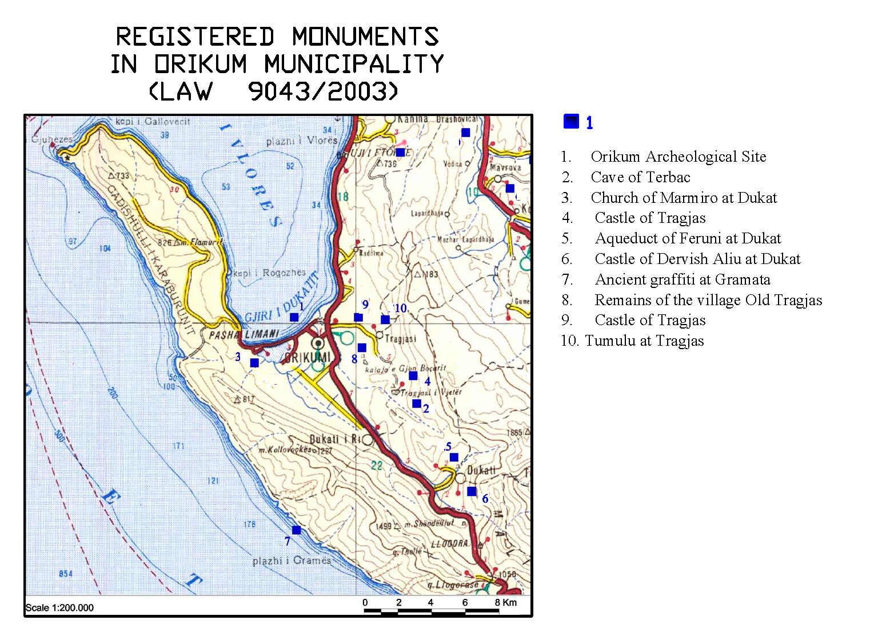
3.5.1 Ethnography, handicrafts, spiritual culture

The actual Orikum city is built and populated between the years 1945 to 1961. It is located near the ancient city of “Orik”. This ancient city was well situated for communication with Greece (Corfu) and was only 40 miles across the sea from Italy (Otranto) making it a convenient stopping point on the journey between Greece and Italy. Ancient sources describe it as a limen, or harbor, but eventually it achieved the status of a city (polis) and from around 230 to 168 BC it issued its own coins with the legend of Orik.
It had military importance under roman rule, serving as a base during Rome's wars with the Illyrians and with Macedonia it was the first city taken by Julius Caesar during his invasion of Epirus and it is documented in his civil wars. The Ottomans renamed Orikum Pashaliman, “the Pasha's harbor”, and the Lagoon still bears this name, as does the nearby Albanian Military Navy base.

The city has been populated mainly on the purpose of Albanian Military navy base and later on by local people of Orikum area ( Dukat, Tragjas, etc). The population of Orikum Municipality area possesses a high level of cultural traditions that originate from a distinguished cultural region called “Labëri”. These traditions are embodied in many fields: architecture, folklore, musicology, gastronomy, etc. In addition to that, Orikum Municipality offers to visitors the value of the spiritual culture. The Dukat area is still revitalizing the tradition of Iso Poliphony classified recent years by UNESCO as cultural heritage. The Dukat`s Trio, its dancing and singing are elements classified in the world Iso Poliphony. This dance is quite unique and is not found in any other region in the Balkans and beyond.

As well traditional dresses are part of the ethnography of the area together with its gastronomy with a lot of influences from Turkish cuisine.

The traditional houses with vernacular architectural are very rare actually. The buildings are in stones and in the inner spaces all the traditional homes had a special chamber for the reception of guests.

3.6 Infrastructure systems

The provision of adequate, sufficient, and sustainable infrastructure facilities is one of the key components of the socio-economic development.
The infrastructure systems will include 6 main sectors:
- transportation sector: divided into 2 sub sectors: roads and ports:
- water sector;
- waste water sector;
- solid wastes, including domestic wastes and construction wastes;
- electricity; and
- telecommunications

The analysis of infrastructure systems in this report will aim at assessing the present situation of the existing facilities in terms of their capacity and condition.

The preliminary overview of the infrastructure sectors considered as basic needs made through the above mentioned components are briefly presented in the Table 10.

Table 10: Preliminary findings of infrastructure components and access to basic needs

Sector | Sub-sector | Assessment | Perspective
Transportation | Roads | Access from the villages to the national roads  Bad condition of few access road  Bad condition of roads to the tourist attractions sites | Project of access road: Radhima village to the national road to be supported under Albanian Development Fund Rural Programs.  Projects linked to  the tourist sites prepared by Municipality  i.e Curch of Marmiro access road
 | Port | One Private Tourist Port “Marina of Orikum”  Basic facilities together with hotel and residential development. | Up to the foreign investor – maximum capacities around 600 berths  Integration of Orikum Marina into the local maritime scene and help the residents prepare to maximise the benefits of nautical infrastructure.
Water | Water-supply  Waste water | Plenty water resources  Problems with organization and management of existing water-supplies  65% of households in Orikum connected with water-supply  the rest with drilling well  In the villages poor condition of water-supply systems, in few cases individuals drilling wells  60% of household connection with sewerage system in Orikum  Septic tanks in the villages  Diffuse and overall  pollution, and  environmental  aggressions | Situation will be improved soon by completion of Civil Works for water-supply system and sewerage treatment unit which is under implementation. The works started few months ago with financial support by the Islamic Bank and Albanian Government.  Necessary to include project with management and organizational issues
Solid waste | Domestic waste  Construction waste | Good management by the cleaning enterprise “Baitel Ltd” but wrong dump site defined by the Municipality for Orikum  Open dump sites all over the area  Construction waste site and domestic waste dumped together in Orikum town, as well few cases along the road | Good trend of Municipality for defining a new place as well the “historical” trend for a regional site ( Qendre Commune and Vlora Municipality)  Control of the territory by the Municipality  Education of the population
Electricity |  | Only one electrical cabin in each village.  100% coverage but insufficient in quantity  and quality of  distribution due to the amortization of distribution lines | More electrical cabins in the villages and improvement of the quality of service by the operator OSSH
Telecommunication |  | Existence of Alb telecom only in Orikum town, in the villages another service provider is functioning All mobile phone operators present in the area  Internet service only in Orikum town

3. 6. 1 Additional information for the ports within the study area and possibility of nautical tourism

In spite of its long coastline, Albania is not a maritime nation. Currently, Albanians’ interest in leisure navigation is limited to small speedboats and other small open boats for fishing. Nautical tourism has not developed in Albania, despite its natural beauties and its excellent position along the Adriatic coast.

Even the Albanian coastline is an attractive area for yachting, the nautical recreational activity along the coast are almost absent due to several reasons:
- Moratorium on the use of speedboats
- The lack of infrastructure and reception facilities;
- Security issues;
- Safety
The actual presence of few ports of different puposes in the study area is mentioned as below:

- Orikum Marina Port
Orikum Marina is the first private investment in Albania, in the sector of nautical Tourism inagurated in 2005. Investors are Italians and their plans included the construction of a 625-berths marina and a residential complex with one, two or three rooms’ apartments. The marina is fully equipped and offer all modern facilities to yachtsmen. Until naw, several regattas are organised by this Port in cooperation with Italian Portual Auhtorities.

- Radhima Port : Approximately 9 km from Port of Vlora, in Radhima is built a stone-loading terminal. The port is now used by the Police as a repository for confiscated vessels used to ferry illegal emigrants to Italy. A large hotel structure has been built on the adjacent property.

- Pasha Liman Port : Orikum city is home to the Albanian Navy, which has its main base of operations at Pasha Limani Port, just west of the Orikum Lagoon. This is still a Military area.

3.7 Summary Status of Vlora) fishing sector. (in particular Karaburun-Sazan Area)

The trend in levels of participation and production in the commercial fishing sector is not similar to that of livestock and agriculture for the described area in Orikum Municipality. These industries were once central to the economy of the Southern Coast.

In 2006, there were 85 commercial fishing vessels registered in the Vlora Port. By 2012, the amount of registered vessels is diminished in 71 vessels, according to the Sailing Vessel Register at Regional Directorate of Border and Migration (RDBM) of Vlora and Durres. It counts 2-4 crew members per vessel or in total around 200 fishermen.
Detailed technical information on the registered vessels considering length, tonnage, engine power, construction year are fund of this Sailing Vessels Register Office of Durres.

However, the information for fishing in the area is collected via informal discussion with fishermen and a detailed questionaire was completed by few of them, due to the limited time for conducting a detailed fishing survey.

The number of active fleets is around 50 vessels which are not spending the same working hours per year. The most active fishermen used to spend at maximum 2300 hours. The total number of trips recorded during 2010 was 130 trips and around 110 trips in 2012. The other fishermen used to spent less time from 900 to 1200 working hours per year. In majority of cases, 80% of the trips are within Karaburun- Sazan area.

The data of fishermen interviews indicate that they are offsetting high fuel costs and diminishing income by deferring maintenance of vessels and gear. The high fuel cost has caused the reduction of trips in the area and the majority of them are mainly catching in Sazan- Karaburun area.

As fishermen reported during interviwes, in terms of both landings and revenue from fishing in the region and in particular Sazan-Karaburun area, the most economically important wetfish fisheries recently have been market shrimp, red mullet and codfish. (*during Nov-Dec 2012, two times are caught sharks by the same vessel, Owner: A. Serjani)

The annual quantity for a vessel whose landings are normally up to 1800-2000 hours per year in Sazan- Karaburun area, the quantity per each species varies from 1500 – 3000 KV, meanwhile shrimp is top-caught species quantity and red mullet has the top-selling price.

With regard to the sale of seafood, mainly the fishermen sale directly to the distribution center and various buyers.

In addition to the information from RDBM and vessel owners, small fishing boats in Sazan – Karaburun are quite usual due to the necessity to reduce the fuel coast. Around 10 boats are in total which are catching fish with angle. The main caught species are: wild seam bream (Karaburun aurata), seabass, dentise (sparidae). These fishermen sell their products directly to the public and/or restaurant at the coast area.

3.8 Aquaculture in Karaburun Peninsula area

The increasing tourist demand for marine fish in Vlora area and demand from its sorrounding cities cannot be met by capture fisheries. Aquaculture production is increased recently and nowadays cage culture is playing an important role in fish market. The increased demand in Vlora district and the appropriate area for this culture of the south-west Albanian coast has been exploited by local and international investors.
In Karaburun peninsula, the rearing of sea bream and seabass is developed by 5 ( five) investors. These are the most consumed fish,
The companies/ investors who operates actually in the area and the respective floating marine cages are given below:
- Ensi Adriatik shpk with 7 cages
- Bello Tris shpk with 8 cages
- Orata shpk with 34 cages
- Vangjeli 2002 shpk with 12 cages
- Xhino shpk with 30 cages

The fish production is possible using HDPE cages of circle and rectang form with perimeter that varies from 30 m, 40m, 52 m, 60m up to a max of 130 m.
The maximum number of species is produced by Orata Ltd which is the biggest investor, is 3,000,000 species followed by Xhino Ltd with 1,000,000 species. The rest of investors produce 200,000 – 300,000 species within 15 months ( April - June) with an average weight of 300 gr per specie.

4. List of References/studies

- Strategy of Vlora Region 2003 – Oxfam
- Management Plan - MedWetCoast Project- 2006
- Heritage Assets Mapping - Albania: Integrated Coastal Management and Clean-up Program - 2005
- “Southern Coastal Region: Priority Assessment Study and SEA as a Tool in Coastal Management in Albania” - WB/METAP
- INSTAT Statistics
- Development Plan of Orikum Municipality
- CRCD Citizens Scoring Card of Public Services in Orikum
- Ministry of Agriculture, Food and Agriculture- DBU Vlore- Vjetar Statisticor
- Orikum Guide
- Southern Coastal Development Plan – ICZMP 2008-Ministry of Public Works and Transport;
- SW Enterprise- Regional Water- Supply and Sewrage Treatment Plant in Orikum Municipality;
- Strategy of Fishing Sector- MFWA

5. Annexes

Annex 1
List of persons contacted:

- Gezim Çapoj – Orikum Mayor
- Ing. Ilir Kukuri – Head of Urban Planning Office
- Nexhip Hysenlako – Specialist of Agriculture Office
- Saimir Braho – Head of Public Service Office
- Shemsi Kondi – Head of “Water- supply and Sewerage” Enterprise
- Elca Bezhani - Head of INSTAT Vlore
- Reshat Xhelili – Specialist of GDAF Vlore
- Zagoll Kabello – Owner of Trout Farming in Tragjas
- Owner of Trout Farming in Dukat
- Gentian Leskaj – Administrator of “Kthesa”
- Albert Ahmeti - fisherman
- Kristo Velaj - fisherman
- Alqi Sota – fisherman
- Abedin Serjani – Owner of fishing vessel
- Flamur Alimani - Owner of fishing vessel
- Mezan Mezani – Owner and head of Fishermen Association
- Dritan Hoxha – Fisherman ( small boats)
- Fejzi Hoxhaj - Sheeper (Karaburun)
- Lesko Hibro – Sheeper ( Karaburun)
- Bilbil Cobaj – Beekeeper ( Dukat Area)
- Markeljan Paja – “Ensi Adriatik” - Administrator of fish farm in Karaburun

Annex 2
Photo from the study area

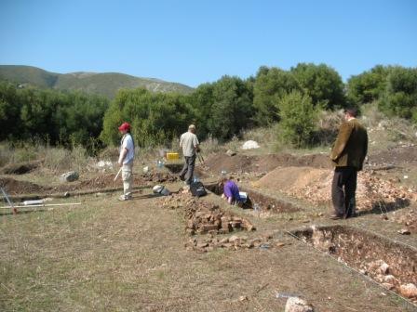 | 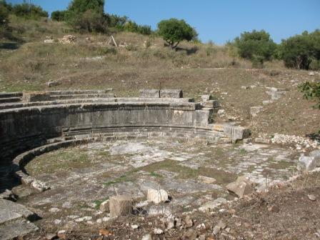
Swiss Archeologs in Orikum Archeological Park | Amphitheatre - Orikum Archeological Park
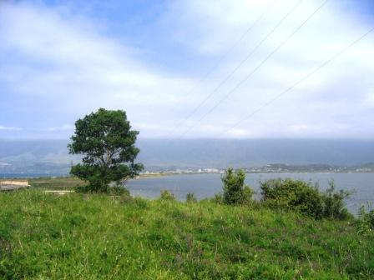 | 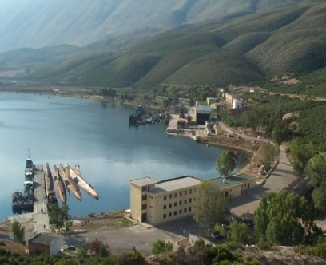
Orikum Lagoon | Pashaliman Navy Base
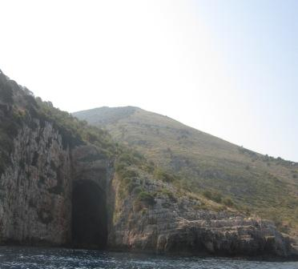 | 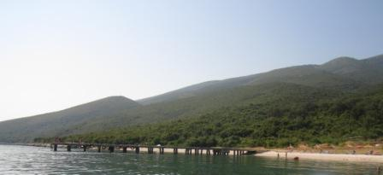
Cave of Haxhi Ali | Karaburun beach
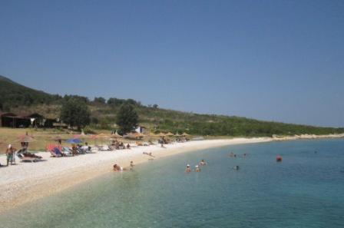 | 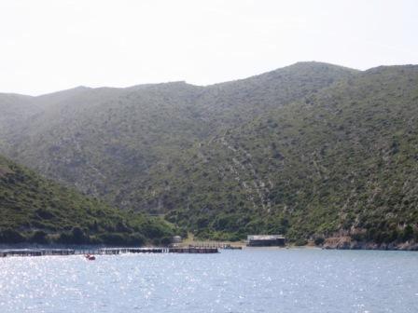
Karaburun beach area | Fish farming in Karaburun Area
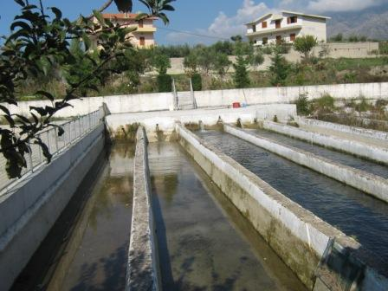 | 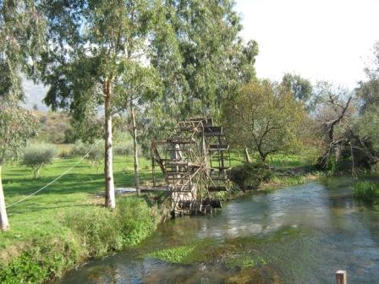
Trout farming tanks in Tragjas | Izvor River
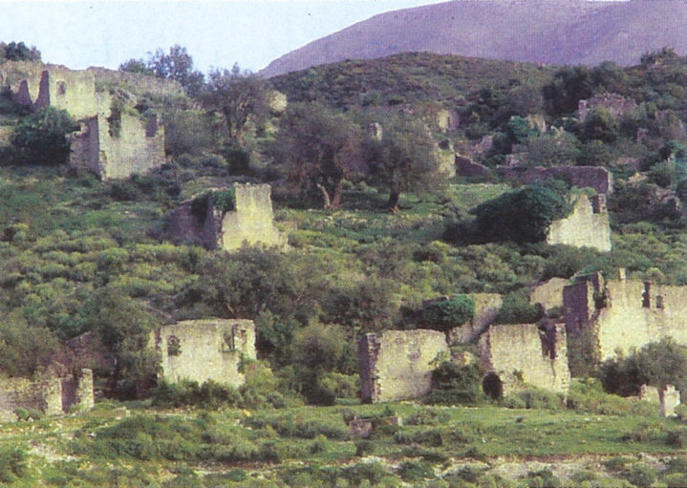 | 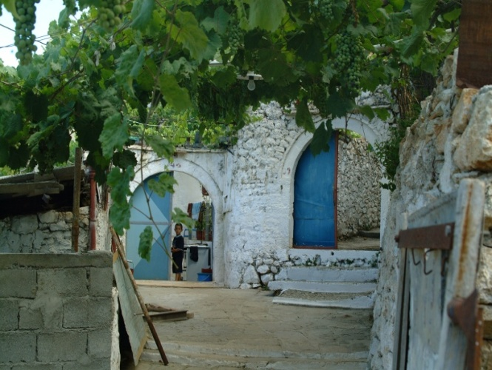
Ruins of Old Tragjas village | Traditional houses built with tones
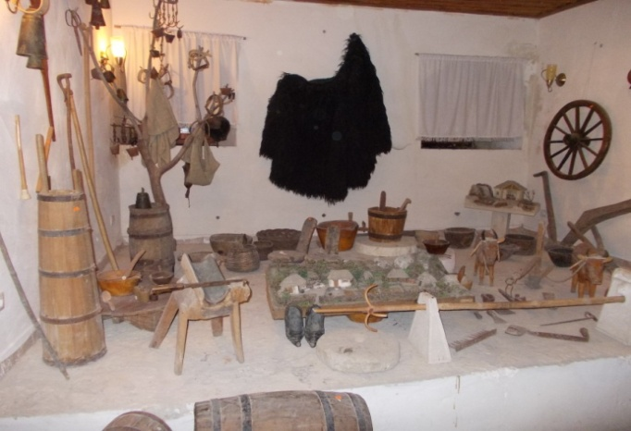 | 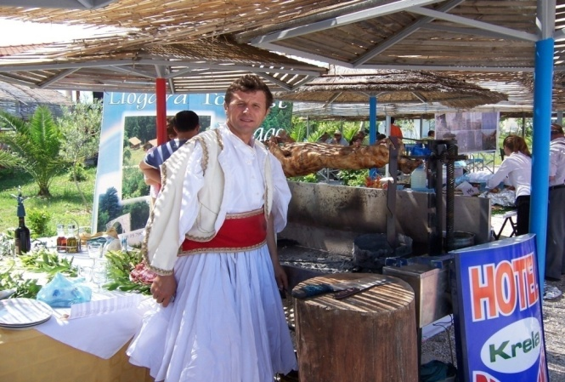
Traditional equipments | Gastronomic Fair in Orikum 2012

