January 27, 2015

FIFTH MEETING OF THE PROJECT BOARD AND MANAGEMENT COMMITTEE OF THE MARINE PROTECTED AREA SAZAN- KARABURUN, NATIONAL PARK LLOGARA AND NATURAL COMPLEX KARABURUN - RREZA E KANALIT- ORIKUM-TRAGJAS-DUKAT

Hotel “Paradise” Vlore

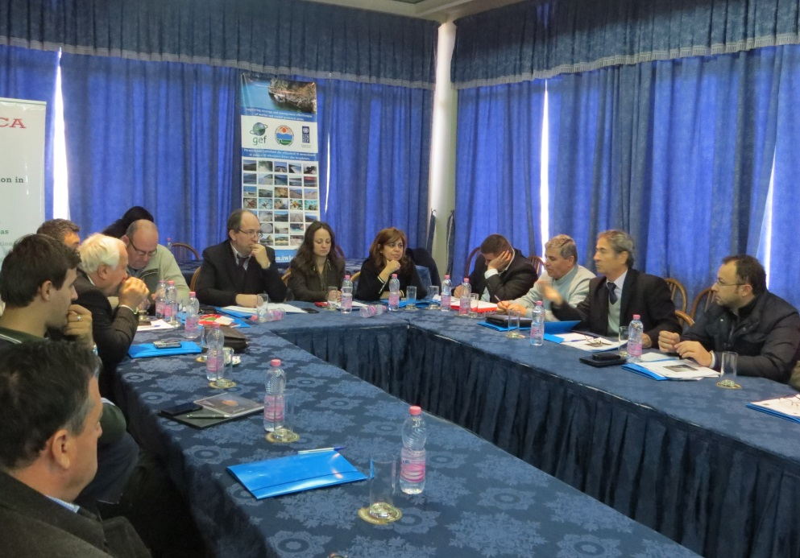

The meeting objectives were:
- Approval of the minutes of the fourth meeting of project board and management committee;
- Approval of the Management plan for Karaburun Sazan area

The meeting was opened by Mr. Ermal Halimi, representative of the Ministry of Environment who thanked the participants for their contribution in the project implementation and the process of good management of Vlora protected areas. In this context he mentioned the serious commitment of the Ministry on the protected areas related with the establishment of the Protected Areas Agency which is a structure which will start its activity soon. The ministry is convinced that this agency seriously contribute to the more effective and functional management of protected areas in the country.

Then Mrs. Elvita Kabashi, UNDP representative, also thanked all member of the Project board and Management committee present in the meeting considering this a very important moment in the further progress of the project because the protected area management plan is under discussion. She also highlighted the constant commitment of UNDP on a better management of protected areas and good operation of the Protected areas Agency expected to be established soon.

The first item on the agenda was the last meeting minutes ‘approval. All participants who were provided with these minutes and read them expressed unanimously their approval.

Afterwards, the PA chief, Mr.Abdyl Cucaj, had a presentation on the protected are status and the problems they face every day. He mentioned that there has been no fire or illegal cuttings, but in case while monitoring they will notice such problems the department inform the competent organs. He emphasized the importance of rigorous law enforcement in the area.

After that, Mrs Znj.Violeta Zuna had her presentation on the project activity in the period between the 2 meetings. She mentioned several work aspect of the project as: implementation of the Memorandums of Understanding, assistance provided on the capacity raising of the PA administration staff, PA staff uniforms and equipments purchase for PA staff METT assessment for 2014. She also mentioned several collaborations with international organisms as WWF on the development of the management plan and Conservatoire du Littoral on the management scheme of Sazani island; revision of the legal framework, collaboration in the process of PAs surface enlargement in Albania. The plan of activities for 2015 was also presented.

Then, Mr. Kujtim Sulçe, in the context of making evident the project achievements, stated his concern that while trying to enlarge the PA surfaces, the effective management of the existing PAs is neglected. He was of the opinion that the objective of PA surface enlargement is compromising the good management and real protection of these areas. According to him, under circumstances that the indicators on real achievements in the area are missing, it’s better to give more attention to the effective management of the protected areas.

Mrs.Violeta Zuna sharing the same concern with Mr. Sulce stressed the fact that while Albania is a member country in several international conventions has also the obligation to fulfill some objectives related with reaching a certain surface of protected areas. The shortages in management should not prevent the accomplishment of this objective. She highlighted that our country has many areas with great biodiversity values which meet the conditions of being proclaimed protected areas. As far as concrete products of the project she stated several of them as : preparation of the Marine protected areas Strategy which is attached to the Biodiversity strategy prepared by the Ministry of environment; development of the management plan for the area Llogara Karaburun and priority actions to be implemented in the area, several measures which would contribute to legislation enforcement in the area, rangers ‘activity and their provision with tools and logistic means for observations and monitoring, etc.

Mr. Nexhip Hysolakoj, deputy mayor of Orikumi municipality, stated the fact that he had followed up since the very beginning the work at the protected area through monitoring the rangers work who make weekly reports. He stressed that we have achieved a lot as far as informative work is concerned; people have more complete information on the existence of a marine protected area because informative tables are put, guides and detailed maps with the area touristic attractions are distributed and several awareness activities have been carried for the community. He mentioned that the moratorium lifting has increased 3 times the number of native and foreign tourists because the service providers had a greater activity. An indicative element of the tourist interest increase is the increased demand to pass Pashalimani checkpoint for visiting Karaburun.

The ministry representative, Mr.Halimi, referring to Mr.Sulçe concern stressed that it’s true that bad management of some protected areas has led to their values’ loss, but we should not give up the challenge of PA surface enlargement. A great devotion and concentration is needed for a more effective management of these areas as a time challenge.

Mr. Sulçe mentioned the Croatia trip experience expressing his wish that our protected areas be really protected areas in terms of the touristic attraction offered and most possible effective management.
Following the discussions on the concern articulated, Mr. Petrit Dervishi, re emphasized the work being carried by the Ministry of Environment on the establishment of the Agency of protected areas which shows that the Government is aware of the inappropriate status of these areas and is thus showing its institutional commitment for giving the proper importance to the PAs management.

Mr. Zamir Dedej, president of INCAs agreed with the concern expressed and stressed that at the local level all must bear their responsibility with the purpose of regulating the management
system for the protected areas.
He stressed the importance of government intervention when things are not moving in the right way. He mentioned the case of rangers in the protected area which were paid by UNDP and not the Ministry highlighting the importance that the government should give to these areas management by implementing real actions in the area and by allocating more funds possible for the better management of the area. He pointed out the importance of sustainable structures which make more effective the real management of the protected areas. He also mentioned some concrete actions which play an important role in the protected areas, as: establishment of the Information center; any intervention for building a small quay; establishment of a diving center and preparation of a diving regulation.

Afterwards, Mr.Genti Kromidha, INCAs expert made an interesting presentation of the whole process of Management plan development in collaboration with WWF which has a long successful experience in development of PAs management plans. He mentioned the hearings with the interest groups, identifications of risks, threats and problems in the area as well as the relation between them and the special natural values of the area human interventions impact and provided a detailed list of priority actions to be accomplished in the area. After that presentation Mr.Sulce articulated another concern on whether the government has made any decision on the Sazani island destination: military or touristic. Mr. Kromidha reminded the fact that the proclaimed protected area includes only the marine part and not the terrestrial one thus stressing the importance of reconfiguring the PA surface for including terrestrial spaces as well.

With reference to the process of preparation and approval of the management plans for the protected areas, Mr.Halimi stated that unfortunately in some cases the management plans prepared has needed revision; so in this context it is important that management plans be realistic, so in this context the management plan prepared for the PA Karaburun Sazan seem to be closer to implementation possibilities.

Looking again to the issue of PAs better management Mr.Dedej referred to Divjaka case noting that when there is real commitment there are achievements even if financial support is not optimal. He emphasized the importance of the balance between the environmental and economic interests of the area and interest groups, as well as the government objectives and possibilities for accomplishing as many of them. In the meantime the community should be active part of the management process, while the staff should have maximum devotion for better accomplishing the objectives.

Mr.Nihat Dragoti, INCAs representative stated that both management plans for Karaburun and Sazani Island should be integrated before submission to the Ministry of environment for approval. He also mentioned that the military troops” have almost given up Sazani” in this context he suggested the Ministry to be very careful for giving Sazani the right profile. He also mentioned that having a small surface Sazani cannot be proclaimed a separate terrestrial protected area because does not meet the surface condition (<500 ha. Looking again to the concern that enlarging of PA surfaces is compromising the management level, he stressed that policies related to EU integration and biodiversity convention require that within 2020 (objective of Aichi strategic plan on Biodiversity approved by decisions taken in Rio +20 and in KeP XI in Hyderabad (India) in 2012) 10% of marine and coastal areas, especially areas of special importance for biodiversity and ecosystem services be protected through the protected areas system effectively and fairly managed, of representative role from the ecological aspect, and as well as other effective measures contributing to area based protection.

According to him the staff of the protected area administration should be part of the management plan preparation process thus making them more committed to the development of the area where they work. He emphasized the importance of setting up a core structure for the protected area including people well trained, capable to face any problem encountered in these areas management. He expressed his good wish and hope that the Agency of protected areas be established within this year and be able to face several challenges.

Mr. Zamir Dedej suggested that a better implementation of the management plan can be achieved through a combination of funds from the Ministry of Environment, UNDP and INCA. According to him several actions specified in the plan can be accomplished by the existing rangers and furthermore for the implementation of more actions specified in the plan, there might be initiated projects because there are many donors interested in the area, who when informed about the management plan might be more concretely and effectively committed in the area.

Mr.Halimi highlighted that the project has a Management committee which according to law supervises the work in the protected area; when a management plan exists this committee should work hard for its implementation. So the management committee must express its approval of the management plan.

Mr.Elvita Kabashi raised the concern if the structure and operational costs specified in the management plan should keep in mind the fact of the Agency of Protected Areas will be established and if the territorial reform impacts the way how this plan will be considered by the local governments units. Mr. Kromidha explained that there is no reason that the management plan includes cost which are a burden to it and provided arguments that in the coming 5 years there would be no separate administration for separate protected areas. The new territorial structure does not impact this plan implementation. In the preparation process there has been working together with Vlora and Orikumi municipality, so in spite of the territorial reform the collaboration with Vlora municipality will be a natural continuation of work.

Mr. Dragoti proposed that local government units should also give their opinion on this plan because this would make them more responsible in the later process of implementation. It was also clarified that the Karaburuni management plan should be submitted separately because Sazani issue is still not finally solved. It was also stated that Ministry of Environment has no right over Sazani because it is not yet a protected area.

Mr.Niko Dumani, expressed his appreciation for the management plan as well as his approval so this plan would pass to the other stages as requested by law and the implementation of priority actions start the soonest possible.

Mr.Mariel Halilaj, prefecture representative, also expressed his appreciation for the considerable work carried for the management plan preparation as well as his approval.

Mr.Simo Ribaj, representative of civil society, also expressed his consideration for this plan as well as its approval proposing that all interested parties should be seriously engaged for implementing as more elements of the plan as possible.

As a conclusion, the Ministry representative thanked all the participants of the meeting requesting their maximal commitment to a better management of the protected area.

Decisions taken by the Management Committee

- Approval of the management plan for the marine area Karaburun-Sazan and proposal to keep on with the endorsement procedures with the Ministry of Environment.
- To start with the management plan implementation, by aiming at the cooperation of all actors, donors, local government, etc. It is suggested to collaborate with WWF and INCA whose plans include activities according to the management plan, including business plan as demanding planning tool.
- Approval of the log frame indicators’ change based on the GEF midterm evaluation suggestions as well as on the approval of the 2015 project activities plan.

