June 13th, 2014

4th MEETING OF THE PROJECT BOARD AND MANAGEMENT COMMITTEE

MANAGEMENT COMMITTEE

MARINE PROTECTED AREA SAZAN- KARABURUN, LLOGARA NATIONAL PARK

AND

NATURAL COMPLEX KARABURUN - RREZA E KANALIT- ORIKUM-TRAGJAS-DUKAT

MINUTES of the meeting

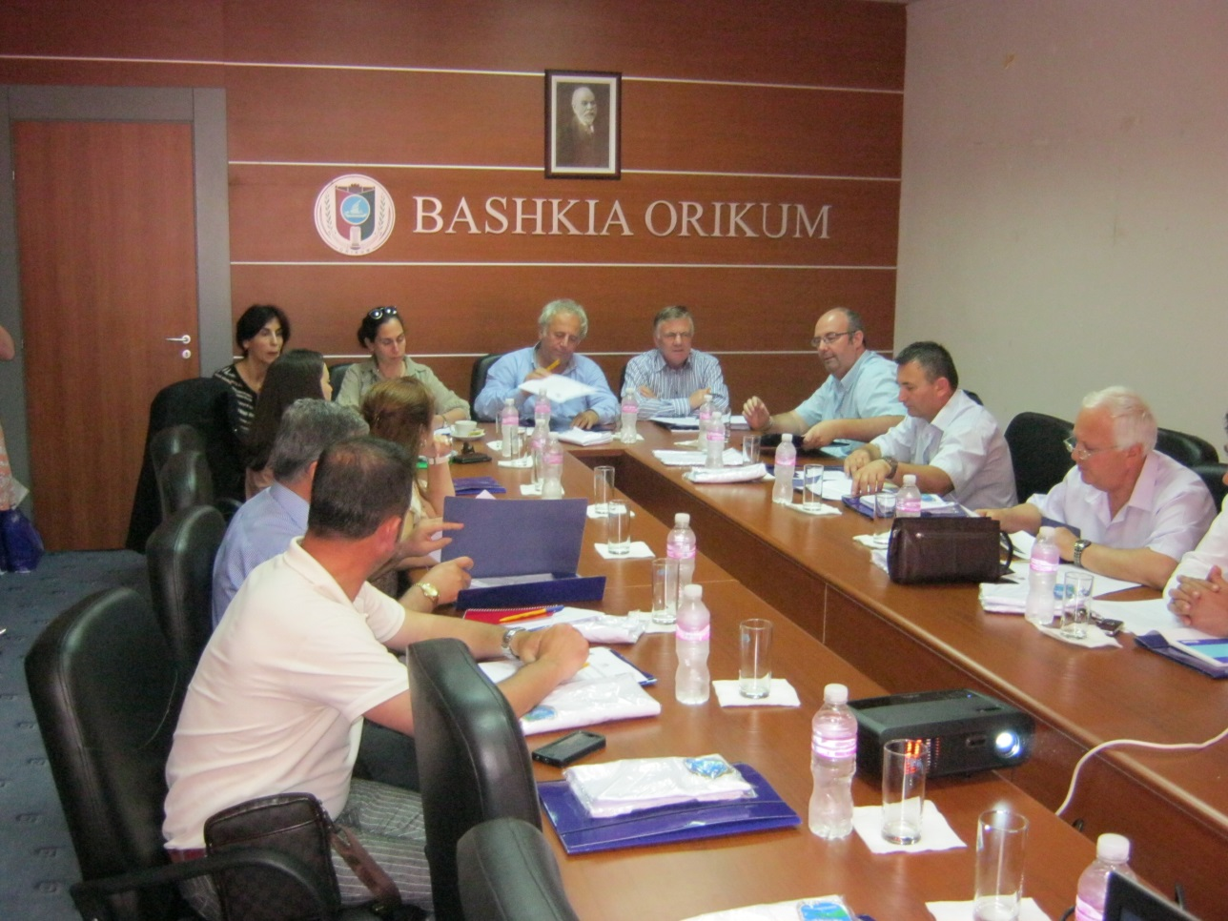

The fourth meeting of the PB and MC of the “Marine National Park Karaburun-Sazan”, “National Park ’Llogara’’, “Natural complex ‘Karaburun-Rreza e Kanalit-Orikum-Tragjas-Dukat’’, was organized in June 13th, 2014, at the premises of the Municipality of Orikumi.
Objectives of the meeting:

- Informing the Board and Management Committee on the project progress,
- Presentation of the progress of the management plan process for MPA and management plan for Sazani

- PRESENTATION AND OPENING OF THE MEETING

Mr. Nihat Dragoti, on behalf of the Ministry of Environment (c/o National Project Director and General Director at the Ministry of Environmental), opened the meeting and welcomed all participants. After excusing Mr. Abeshi for not being possible to attend the meeting, he thanked in particular Mrs. Yesim Oruc, UNDP Country Director for her presence as well as invited representatives from WWF and Conservatoire du Littoral (CdL).

Mrs. Yesim Oruc extended her thanks and appreciation to local authorities and Ministry of Environment for the cooperation and efforts they put in sustaining this management mechanism.

Then the Minutes of the last (3rd) meeting were endorsed and Agenda of this meeting was approved.

Mr. Abdyl Cucaj in his capacity as site manager at the Forestry Directory of Vlora made a short presentation of the actual administration status, progress of activities so far, as well as cooperation and synergies with the UNDP project. He informed about the general information on PA in the region with focus on MPA K-S area, listing as the main issues the lack of resources and illegal activities, etc.

This was followed by the presentation of Ms. Violeta Zuna as project manager informing on the UNDP project progress for the period since last meeting, main planning of the second 2014 semester and the challenges ahead. The main issues highlighted were the buffer zone management guideline report (accomplished recently with project expertise), the monitoring and logistic equipment for the MPA administration, cooperation with the National Coastal Agency in establishing the watch / guard towers in Orikumi beach, development of the documentary film for the marine biodiversity, study visit accomplished in Marine parks in Croatia (Mljet, Kornati and Telascica), the coastline cleaning up campaign with Albanian Volunteers Corps [Narta (Zvernec) and Shengjin (Kune)] as well as cooperation and scientific expertise from Conservatoire du Littoral and WWF / INCA in preparing the management plan for MCPA S-K. The International Biodiversity Day has been celebrated on 22 May through awareness activities in Orikumi.

Mr. Nexhip Hysolakoj as the vice mayor of Orikumi municipality reported on the progress with enforcement measures and mainly on the MoU implementation, including activities that Orikumi municipality has organized last months, site patrolling and promotional activities.

The meeting continued with WWF /INCA presentation on Management Planning process, synergies and development, vision and objectives agreed. It highlighted such cooperation as a very important tool and synergy provided through the GEF/UNDP. Focus was given to preparatory activities during 2013, plan development (vision, values, threats, themes, subthemes and goals), meetings with decision makers, and workshops with stakeholders (identification and analysis, semi-structured interviews). The draft vision of the managers of K-S MCPA is set as: ‘Karburun-Sazani is a well-managed marine area of outstanding naturalness, where resources are used sustainably to support a diversity of tourist offer’. The next steps foreseen are development of a zoning plan, discussion on potential and sustained governance of the MPA, information through media, internet, bulletin boards, etc. while, recently there are made intensive efforts with local and international experts with studies and assessment reports (nature based activities, sustainable tourism-related certification), communication tools, and training and public hearing practices.

Ms. Celine Damery and Mr. Pere Tomas Vives – from the CdL (a French public agency for coastal conservation, institutional and technical assistance on coastal zone management at international scale) presented their work regarding the Sazani management plan process. She informed about the coordination of the PIM Initiative for Mediterranean Small Islands and cooperation with Albanian organizations since 2011. They have accomplished 2 field missions on Sazani Island for ecological diagnosis, evaluation of seashore ecological quality and study visit of an Albanian stakeholder delegation in France. For the 2014-2017 PIM project will support activities on Sazani island namely preparation of Sazani management plan, closely coordinated with Karaburun-Sazan, including also measures of ecological engineering, visitors facilities, important heritage (ecological, historical, cultural, landscapes). They presented a potential scenario for the future designation of Sazani island as PA compatible with existing situation or Karaburun-Sazan Management Structure for the whole area (to provide public welcoming and awareness raising activities etc.) or logistical base for scientific missions or ecological restoration activities.

Mario Kalus, Director of Forestry Service at Vlora – He reiterated the interest to resume the MoU with UNDP MCPAs Project, which has been interrupted earlier due to a problematic performance of the former senior official of the DFS. This, according to him, would increase monitoring on MPA K-S and also capacities of the local staff. Ms. Zuna welcomed such request, subject to argued budget and well defined activities. Mr. Dragoti referred to the reform actually undertaken at the forestry services and called for prudence and efficient use of all resources available; in this respect he welcomed UNDP resuming the former MoU with forestry service department but highlighted at the same time serious commitment and realistic use of earmarked support; the PA administration now is designed as a Department with regional office. The Ministry cannot yet afford enough capacity on MPA therefore it would help if DFS of Vlora cooperate with UNDP project on MCPAs and take over efficient and correct implementation.

Mr. Dragoti highlighted the need for review and consultation of the buffer zone management guidelines with the MoE in order to allow for a more practice oriented and site level usage of this guide tool.

Mr. Kujtim Sulce – Director of Environment Regional Agency of Vlora appreciated the project progress but called for more attention and support to the DFS namely in resuming the MoU arrangement.

Mr. Simo Ribaj – SEEP NGO drew attention for more NGO engagement during the MCPA management and conservation activities, particularly now that there is not yet a MCPA administration in place. He attested for very close cooperation with the project office in several activities with an increased awareness among several resource users of the marine area. He had also positive comments on the reporting period work progress, and reassured for active commitment of the SEEP to forthcoming activities.

- CONCLUSIONS AND CLOSING OF THE MEETING

Decisions taken by the Management Committee

- All members of the MC reached common understanding that it would be more effective and rational to incorporate both management plan for MPA, for Sazani island and business plan for tourism in one document.

Agenda of Management Committee MPA & Project Board Meeting
Orikum, 13th June 2014

Timing | Issue | Person in charge
10:30 | Opening remarks | MoE& UNDP representatives
10:40 | Endorsement of the Agenda and the Minutes of the last meeting | Head of Management Committee
10:45 | Presentation of the actual administration status of the NP of Llogara, Natural Managed Reserve of Karaburun and MPA Karaburun-Sazan | Head of PAs in Vlora Region  Abdyl Cucaj
11:15 | Information on the UNDP project progress from last meeting | Violeta Zuna, UNDP Project manager.
11:30 | Progress on enforcement measures | Municipality of Orikumi  Nexhip Hysolakoj
11:45 | Management Plan preparation, vision and objectives | WWF/ INCA
12:15 | Discussions | Participants
13:30 | Conclusions and closing of the meeting | MoE& UNDP
13:45 | Display of the film “One day on the coast” – prepared by the project
14:00 | Cocktail

ANNEX II
List of Participants
- Yesim Oruc Country Director, UNDP CO
- Nihat Dragoti Ministry of Environment
- Gezim Capoj Mayor, Orikum
- Nexhip Hysolakoj Orikumi municipality
- Mario Kalus Regional Forestry Service department
- Abdul Cucaj Regional Forestry Service departament,PA chief
- Kujtim Sulce Regional Environmental Agency
- Reshat Xhelili Fishing Inspectorate
- Mariel Halila Vlora Prefecture
- Simo Ribaj SEEP NGO
- Vasil Bedini Touristic operator
- Elvita Kabashi Programme Associate, UNDP CO
- Violeta Zuna Project manager, UNDP
- Eno Dodbiba Technical expert, UNDP
- Petrit Dervshi Project local Office
- Doreid Petoshati Project local Office
- Ema Paco Admin finance assistant
- Zamir Dedej INCA
- Marinela Mitro INCA
- Giuseppe Di Carlo WWF
- Celine Danery Conservatoire du Littoral
- Pere Thomas Conservatoire du Littoral

