March 3rd 2014

3rdMEETING OF THE PROJECT BOARD AND MANAGEMENT COMMITTEE

MANAGEMENT COMMITTEE

MARINE PROTECTED AREA SAZAN- KARABURUN, LLOGARANATIONAL PARK

AND

NATURAL COMPLEXKARABURUN -RREZA E KANALIT- ORIKUM-TRAGJAS-DUKAT

MINUTES of the meeting

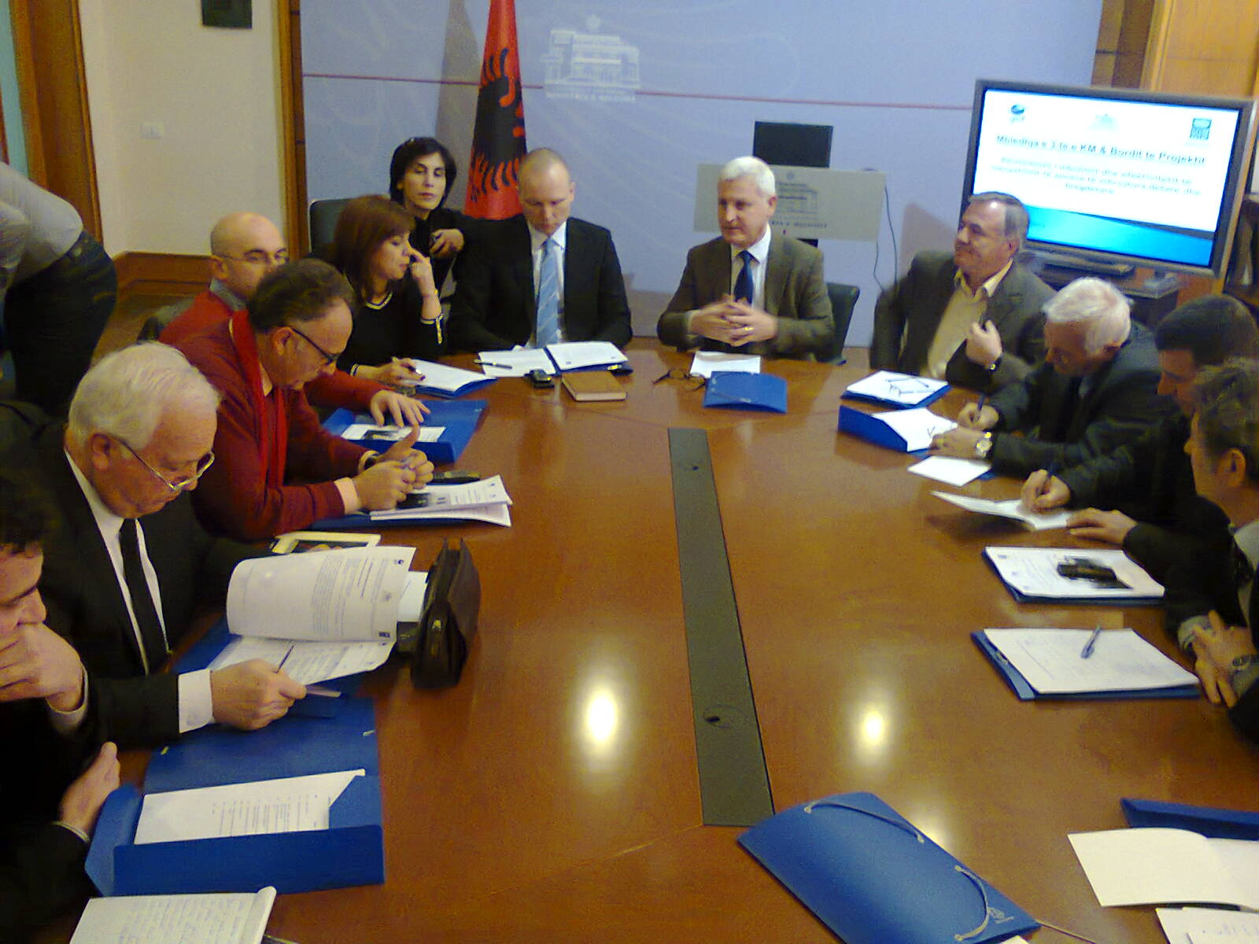
The third meeting of the Project Boards and Management Committee of the “Marine National Park Karaburun-Sazan”, “National Park ’Llogara’’, “Natural complex ‘Karaburun-Rreza e Kanalit-Orikum-Tragjas-Dukat’’, was organized in February 3rd, 2013, at the premises of the Ministry of Environment in Tirana.
Objectives of the meeting:

- Informing the Board and Management Committee on the 6 months project activities, especially on the progress of the MoU implementations, accomplished expertise and consultancies, as well as other issues
- Presentation and approval of the working plan/activities for 2014

- PRESENTATION AND OPENING OF THE MEETING

Mr. Pellumb Abeshi, National Project Director and General Director at the Ministry of Environmental, opened the meeting giving the welcome to all the participants. He made a brief presentation of the MC institutions responsibilities and goals. Mr. Abeshi thanks in particular Mr. Freddy Austly, UNDP Deputy Country Director. On behalf of Ministry of Environment, expressed gratitude for UNDP office that in those last years are giving a very quantitative and qualitative assistance, to the Ministry of Environmentand its local structures on management and capacity building of MPA areas. Mr. Abeshi invited Ms. Violeta Zuna to moderate the MC meeting.

Ms. Zuna passed the keyword to Mr. Freddy Austly, Deputy Country Director UNDP in Albania.

Mr. Freddy Austly, on behalf of UNDP office in Albania, gave the welcome to participants and thanked the Ministry of Environment for the collaboration with the UNDP MCPA project. Also he appreciated the efforts and contribution of the project office in establishing and strengthening the management patterns of the pilot MCPA. Particularly he extended his thanks to the MoE for the fruitful and continuing commitment and cooperation with the project activities.

Approval of the Minutes of the 2nd MC Meeting and Agenda

Ms. Zuna asked the MC members to approve the minutes of 2ndmeeting of MC. There was no comment on terms of the minutes of last meeting, hence it was approved.
She passed at the approval of the meeting agenda. No one had any objection to the meeting agenda.

Mario Kalus – Director of Forestry Service at Vlora
Mr. Kalus informed about the general information on protected areas in Vlora bay and more specifically for MPA K-S area. The main problems in the area are the illegal building construction. Also a big problem is the infrastructure and information tables on PA of Llogora. The director requested more collaboration with local authorities on conservation and protection of this area.
On MPA K-S management, Mr. Kalus expressed directly their interest to resume the MoU with UNDP MCPAs Project, interrupted a year ago, to increase monitoring on MPA K-S and also on capacity building for future structure.

Ms. Zuna welcomed the request of Mr. Kalus to resume the MoU with the project and hoped that this will be the right time for a long and close collaboration.

Mr. Abeshi on behalf of Ministry of Environment sustains Directorate of Forestry Service of Vlora to increase its effective management on MPA. He said that the Ministry of Environment will undergo restructuring process and PAs will have a Department and it will also have some regional offices. The Ministry doesn´t have enough capacity on MPA and will be very useful to DFS of Vlora sign the MoU with UNDP project on MCPAs. K-S MPA is the first and only one in Albania and for this reason all the attention of MoE is focused on this area. Mr. Abeshi mentioned also the lack of legislation and the application of the existing one and this is one of the biggest problems.

Mario Kalus: Very important role of local community on protection of this area and the need of more frequent inspections in the area.

On the reorganization issue, Mr. Abeshi told that the Ministry of Environment will have a Directorate of Control and Management Forestry Directorate which will help us for more effective inspection.

- PRESENTATION OF THE UP TO DATE PROJECT PROGRESS BYMrs. VIOLETA ZUNA

Ms. Violeta ZUNA, Project Manager, made a detailed presentation of the project activities during this reporting period (July 2013 - February 2014).

The main issues highlighted are:
- Consultancies and technical reports from national and international experts related to:
- Main findings of the consultancies related to legal issues and buffer zones
- Activities for promotion of the MPA nationally and internationally
- Activities in the framework of the new Government first100 days
- Collaboration with foreign organizations like CdL for different studies in Sazani island and WWF for the managemnt plan of MPA
- Plan of activities for 2014

Discussions and comments on Mrs. Zuna presentation

Mr. Dragoti- Representative of the MoE, Head of Protected Areas Sector. He highlighted the need for review and consultation of the reports within the MoE in order to endorse and take them further with implementing recommendations; he appreciated the cooperation and support that UNDP provided during the 100 day government program focusing on information, communication, public awareness, cleaning and forestation in the PA and adjacent buffer zones;

Mr. Fatos Bundo from the National Agency of Coast Protection informed about the initiative and procurement that this agency will soon launch for building and establishing two watch towers for coastal guards. Mr.Bundo requested to be member of MC as representative of NACP. He also informed about the organization of NACP which will have 4 regional offices all over Albania and the local office of Vlora prefecture will be in Orikum.

Mr. Xhemal Mato – NGO representative asked about territorial administration and responsibilities of NACP?

Mr. Bundo explained that the responsibilities of NACP will regulate by a new law. Agency will be under Prime Minister jurisdiction.

Mr. Abeshi stressed the importance of MoE local institutions and their role on protection and conservation.

Mr. Kujtim Sulce – Director of Environment Regional Agency of Vlora welcomed the establishment of NACP and hoped that this institution will cooperate closely with local institutions to achieve the biodiversity protection and conservation.

Mr. Nihat Dragoti - On behalf of MoE he answered about the request of ACP to become member of MC. He informed that any future action will be taken confirm legislation and the same way will apply on territory management.
He also stated that it is not the MC responsibility to include new members but it is the Minister´s responsibility to decide about membership. So the ACP should send a written official request sign by General Director of ACP requiring to become member of MC.

Mr. Niko Dumani from the Prefecture of Vlora region appreciated the inputs, commitment and results achieved from the Orikumi municipality and also called for more support and assistance of the local authority in order to better apply their measures towards marine biodiversity conservation and management , as crucial actors in this respect.

Mr. Mezan Mezani as chairman of the OFM highlighted the important role of the coordination measures among institutions locally and centrally, line ministries, enforcement agencies etc., he pointed out the latest measures of the Ministry of Agriculture in banning hunting of dateri as well as the efforts to fight illegal fishing , particularly fishing with dynamite

Mr. Nihat Dragoti clarified that the fishery inspectorate is still under the Ministry of Environment regardless the fishery directorate is moving under Ministry of Agriculture; therefore we must still be attentive and encourage cooperation within the new patterns established between the two ministries.

Mr. Saimir Beqiraj form the Faculty of Sciences recalled the discussion regarding the buffer zone definition and proposed that the terrestrial area be included in the management planning – this was taken further from Mr. Dragoti who informed that the Ministry of Environment is elaborating the necessary provisions to amend the law for the purpose of buffer zone management and conservation; he also addressed the ministry representative the urgent need for setting up the MCPA administration which was accepted from Mr. Dragoti as a problem already settled for solution in a wider perspective for all PA country wide. He also informed that there is still an opinion to develop a new law for MCPA.

Mr. Mendim Baçi: The representative of “BioAgro” NGO which operates in Vlora region, reassured for very tangible result of the project activities in the target areas, with prominent indications of the awareness among several resource users of the marine area. In addition he commented well on the reporting period presented supporting all implemented activities and agreed on the work-planning for the 2014, particularly in view of awareness and information raised as well as enforcement of legislations;

Mr. Genti Kromidha informed that INCA will organize on the 13thMarch the first seminar on management planning process with participation of all stakeholders aiming to prioritize objectives of the management plan.

Mr. Nexhip Hysolakoj reported about the activities that Orikumi municipality has organized last months in the site patrolling, establishment of the informative tables and promotional activities, negotiations with the military authorities regarding shift of the entrance and provision of higher access into the area (the cultural and historical attractions).

Mr. Xhemal Mato pointed out the need for engaging the NGO service to provide assistance for the management and conservation tasks to MCPA administration. Following this issue, Mrs. Zuna and Mr. Dragoti clarified that this is a competitive process that will be open and invite all actors capable and interested in providing kind of service in addition to limited budget which yet does not allow for such exercise. She also clarified that all these tasks are envisaged to be implement in the scope of institutional responsibilities that includes actors such as Forestry Service, Ministry of Environment, Municipality of Orikumi, Agency for Coastline Protection, etc.; notwithstanding the role of NGO /CBO is very important and is under permanent attention from the UNDP and Ministry of Environment side, and encouraged at any instance and activity undertaken; whereas Mr. Sulce called for more mediatic and public hearing activities with presence of the NGOs.

- CONCLUSIONS AND CLOSING OF THE MEETING

Decisions taken by the Management Committee

- The MC approved the working plan for 2014

ANNEXI

Agenda of the Meeting of Management Committee and
Project Board
Timing | Issue | Person in charge
10:00 | Opening remarks | MoE& UNDP representatives
10:10 | Endorsement of the Agenda and the Minutes of the last meeting | Odeta Çato, Head of MC
10:15 | Presentation of the actual administration status of the NP of Llogara, Natural Managed Reserve of Karaburun and MPA KaraburunSazan | Forestry Service Department  Marius Karlo
10:45 | Information on the UNDP project progressand activities for 2014 | Violeta Zuna, UNDP Project manager.
11:15 | Progress with enforcement measures and MoU implementation | Municipality of Orikumi Nexhip Hysolako
11:30 | Progress with enforcement measures and MoU implementation | Fishery Association  Mezan Mezani
11:45 | Preparation of ecological evaluation for a new MPA, Porto Palermo | Zamir Dedej, INCA
12:00 | Open discussion | Participants
12:30 | Various issues on which decision will be taken by the Management Committee | Participants
13:30 | Conclusions and closing of the meeting | Odeta Çato, Head of MC

ANNEX II

List of Participants

Komiteti i Menaxhimit

Zona e Mrojtur Detare Sazan-Karaburun, Parku Kombetar Llogara

dhe

Kompleksit Natyror Karaburun - Rreza e Kanalit- Orikum-Tragjas-Dukat

NR. | INSTITUCIONI | EMER MBIMER
1. | Ministria e Mjedisit | Pellumb ABESHI
2. | Ministria e Mjedisit | Nihat DRAGOTI
3. | Ministria e Mjedisit | Elvana RAMAJ
4. | UNDP | Freddy AUSTLI
5. | UNDP | Elvita KABASHI
5. | Prefektura Vlore | Niko DUMANI
7. | Bashkia Orikum | Nexhip HYSOLAKOJ
8. | Drejtoria e Sherbimit Pyjor - Vlore | Mario KALUS
9. | Keshilli i Qarkut Vlore | Ajen GRABOVA
10. | Agjensia Rajonale e Mjedisit | Kujtim SULCE
11. | UNDP, MCPAs Project | Violeta ZUNA
12. | UNDP , MCPAs Project | Eno DODBIBA
13. | UNDP , MCPAs Project | Petrit DERVISHI
14. | UNDP , MCPAs Project | Ema PACO
14. | UNDP , MCPAs Project | Doreid PETOSHATI
15. | Instituti per Mbrojtjen e Natyres ne Shqiperi - INCA | Genti KROMIDHA
16. | Shoqata ``Edukimi Social dhe Mbrojtaj e Mjedisit - SEEP | Simo RIBAJ
17. | Shoqata e Bujqesise Organike | Mendim BACI
18. | Parku arkeologjik Amantia-Orikum - Ministria e Kultures | Novruz BALRAMI
19. | Fakulteti i Shkencave te Natyres | Saimir BEQIRAJ
20. | Eko levizja | Xhemal MATO
21. | Organzata per menaxhimin e peshkimit, Vlore | Mezan MEZANI
23. | National Agency of Coast Protection | Fatos BUNDO

