July 23, 2013

2ND MEETING OF THE PROJECT BOARD AND MANAGEMENT COMMITTEE

MANAGEMENT COMMITTEE

MARINE PROTECTED AREA SAZAN- KARABURUN, LLOGARA NATIONAL PARK

AND

NATURAL COMPLEX KARABURUN - RREZA E KANALIT- ORIKUM-TRAGJAS-DUKAT

MEETING MINUTES

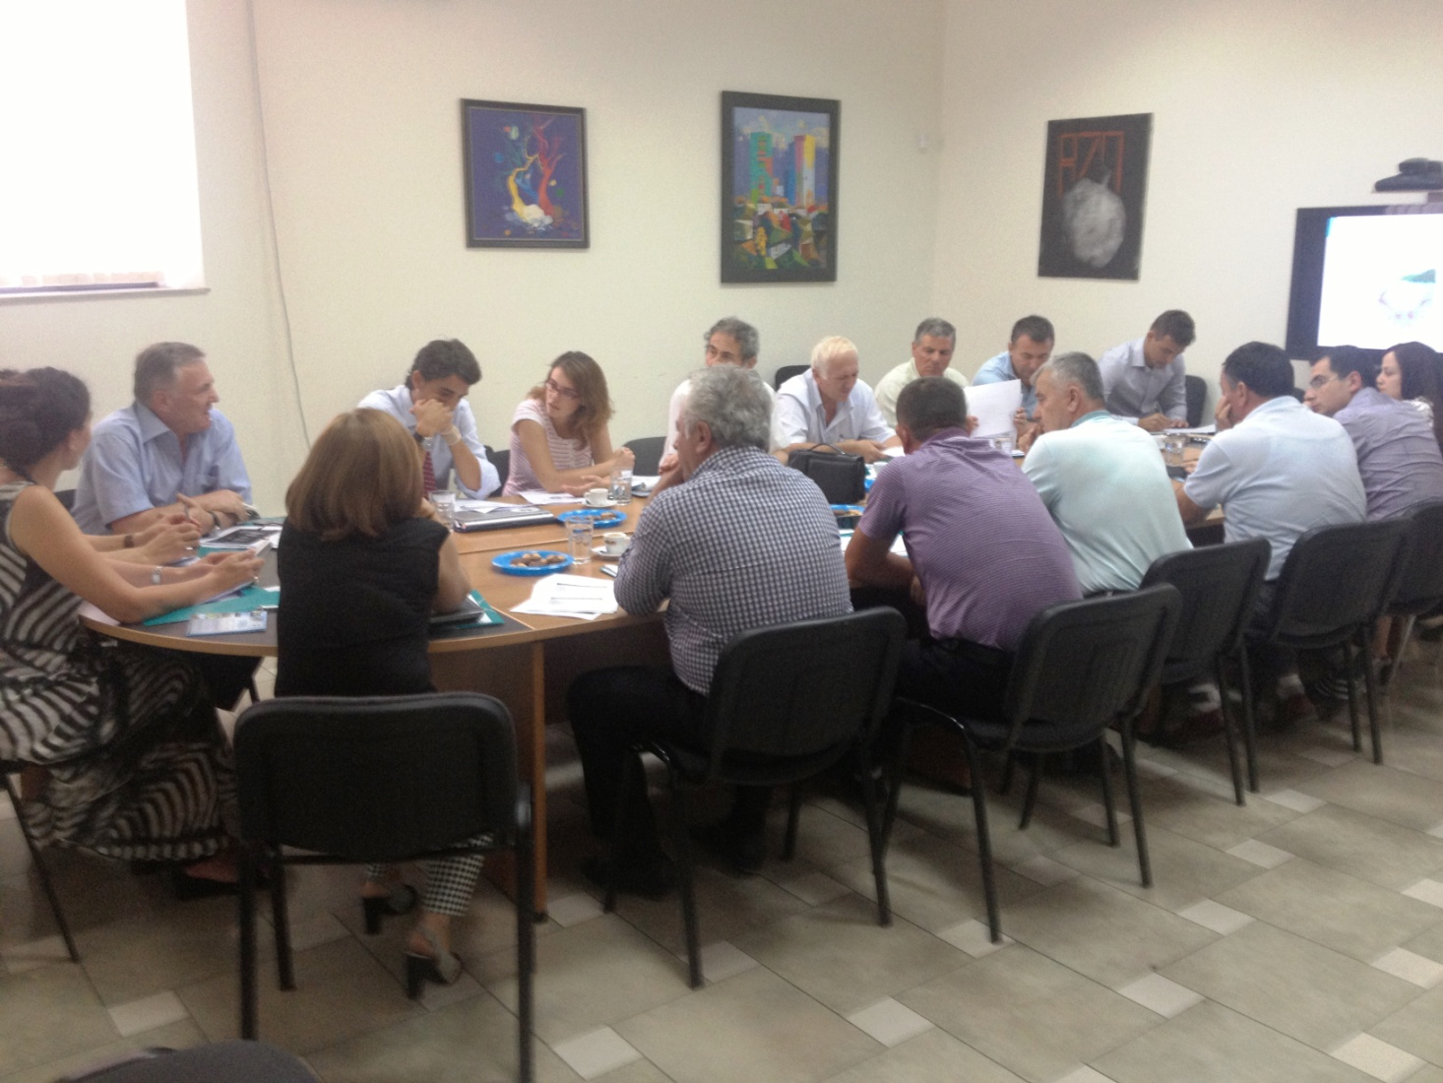
The second meeting of the Project Boards and Management Committee of the “Marine National Park Karaburun-Sazan”, “National Park ’Llogara’’, “Natural complex ‘Karaburun-Rreza e Kanalit-Orikum-Tragjas-Dukat’’, was organized in July 23, 2013, at the premises of UNDP CO in Tirana.
Objectives of the meeting:

- Informing the Board and Management Committee on the 6 months project activities, especially on the progress of the MoU implementations, accomplished expertise and consultancies, as well as other decision making issues
- Selection of the official Logo of the MPA Karaburun-Sazan
- Presentation of other projects/activities in the area
- Starting the process of Management plans development for the MPA Karaburun-Sazan

- PRESENTATION AND OPENING OF THE MEETING

Mrs. Yesim Oruc – UNDP Country Director in Albania

Mrs. Oruc thanked the present members for their availability and participation in the second meeting of the Management Committee. In the meantime she congratulated the project team for the very good work carried up to now and stated as well as the important support provided by the local institutions and actors. This opinion was brought to the attention of the meeting as a finding resulting from her May 2013’ visit in Vlora on the occasion of the Environmental Film Festival event, when she was introduced with the local office work and had several meetings with local actors and interested stakeholders.

In course of her speech Mrs. Oruc mentioned several essential elements which are important to the project implementation:
- Raising of capacities of the MPA
- Cooperation with some central and local institutions
- Attention and proper commitment of the local institutions and actors toward such initiatives

She shared with the audience her conviction on the importance that all actors and factors included in the development and protection of this area should be committed in its management improvement. Positive and fruitful cooperation should characterize the ongoing work.

Mr. Nihat Dragoti- Representative of the MEFWA, Head of Protected Areas Sector

Mr. Dragoti thanked the participants, considering the participation in the meeting as a very good sign of interest not only of the local institutions and actors who are very important in this process. He also thanked the project team for the up to date work carried in the site and expressed also the gratitude of the institution he represented for the UNDP work in Albania and the commitment and attention of Mrs. Oruc in the environmental issues of the country. He also referred to the project collaboration with the Department of Forestry service in Vlora.

Mrs. Oruc shortly interferes to specify that MEFWA is also co-financing the project.

Approval of the meeting agenda

Mrs. Oruc after inviting all participants to once again look at the agenda with the purpose of approving it invited them to provide any comments or suggestions (See Agenda in Annex 2). Under circumstances that there was no comment or suggestion, she then invited Ms. Violeta Zuna, National manager of the project to have her presentation.

- PRESENTATION OF THE UP TO DATE PROJECT PROGRESS BY Mrs. VIOLETA ZUNA

Ms. Violeta ZUNA, Project manager, made a detailed presentation of the up to date project progress.

Thanking the board members, she informed them on the project work carried in the first half of the current year. She highlighted once again the importance of the MCPAs and especially of the MCA K-S as an asset and richness of the nature and biodiversity. She also mentioned the main objectives and goals of the project, as well as its short and long term objectives. A special consideration was given to the long and satisfactory process of MoU implementation with the Orikumi municipality and Department of Forestry Service in Vlora, for the implementation of the priority measures in law enforcement and monitoring of the illegal actions in the area.

In course of the referred period, several actions were undertaken related to the management and administration of the MPA K-S in special, but also in general for all the marine and coastal protected areas; MPA K-S is considered as a pilot area for the other future protected areas in the country.
The main issues highlighted are:
- Consultancies and technical reports from national and international experts related to:
- proposal of a model administration for a MPA
- constituting of the inter sectorial forum for the MPA network, as an advisory body for the governmental institutions
- socio economic analyses of the MCPAs in general, and especially of the National Marine Park Karaburun-Sazan, aiming at making evident the advantages and disadvantages
- consultancies, tourism and ecotourism related issues in the protected area K-S

- The process of the Marine and Coastal Protected Areas Strategic Plan development has been of special importance as far as the selection criteria and announcement of other MCPAs in Albania.
- Improved information and communication in and for the MPA S-K as informative tables at the entrance of the protected area thus providing better information to the visitors and tourists not only on the area status but also on its values.
- On the occasion of the International Biodiversity day, the project office organized and coordinated successfully the Environmental Film festival initiated by the EU office in Tirana and Vlora.
- The Park logo design delivery process, the evaluation of the proposed logos carried in close collaboration with the MEFWA and the selection of the best proposed design was completed.
- There has been a close collaboration, monitoring and diagnostic activities in Sazan Karaburun habitats in the framework of the PIM initiative, which is being implemented under the leadership of Conservatoire du Littoral in collaboration with Tirana and Vlora Universities and APAWA, Albanian environmental NGO.

Discussions and comments on Mrs.Zuna presentation

Mr. Dragoti: He stated his support for the project and up to date progress. He had concerns about the proposed structure of the MPA administration, considering it an utopia and a structure almost impossible to be used under Albania’s conditions. According to him the proposal should take into consideration the financial resources as well as the related high cost, which also includes the wide geographic surface to be covered and the insufficient number of rangers. He said that there should be a proposal for a more adoptable and real structure of the MPA administration.

Ms. Oruc: She congratulated Ms. Zuna on the up to date work carried by the project team and further elaborated on Mr. Dragoti comment acknowledging the need of a more realistic administration but according to her, this should be based on a professionally qualified proposal as well as on national and international relevant expertise. She considered the structure proposed to the MEFWA as appropriate but she mentions that it is opened to further discussions so that it be adopted to an alternative model between the proposed structure and the one which can be more realistically applied in Albania through the relevant policies of the MEFWA. Mrs. Oruc once again clarified that the proposed administration structure is the ideal model how a relevant administration should be and how a MCPA administration should function in general. Her opinion was also strongly supported by Mrs. Zuna.

Mr. Dragoti: In spite of that he once again highlighted his opinion about the MCPA administration. He stated that the MCPA administration should be separate from the structures of the Forestry Service Department and the rangers should be trained for better skills while accomplishing their tasks.

Mr. Niko Dumani: He is the environment representative in Vlora Prefecture required from the central decision-making institution, MEFWA to be more active and treat with more priority the MCPAs announcing by proposing the most possible one with the aim to conserve the Albanian unique biodiversity . He also asked the ministry representative that the protected proclamation be made in line with the European Union proposals and standards.

Mr. Gezim Capoj: The Orikumi mayor expressed his availability and willingness for further collaboration with UNDP and made evident the fact that the rangers contracted as per the MoU signed are selected based on the experience and knowledge on the related area. Taking into consideration the specific problems in the area, he suggested that they all ask for a greater commitment and clear politic good will for improving the legal and structural framework and the MCPA’ management.

Mrs. Oruc: She mentioned regarding the MCPAs that Albania should have more such areas not only in numbers, but in surfaces covered.

Mrs. Zuna: Following the same line of the above mentioned discussions, she clarified some issues and answered some questions as in the following:
- Related to the percentage of the announced protected areas, they abide by the directives and requirements of the EU and different Biodiversity conventions;
- Related to the proposed Administration structure, this one is the best possible, its complete or partial implementation or the administration dependence are issues to be solved by the MEFWA or other political and institutional instruments which might be developed and introduced by the new government.

Mr. Dragoti: He once again reiterated his opinion and attitude of not being against the proposed structure but highlighted the fact that it should be in conformity with the area structure and realistic implementation possibilities.

Mr. Mendim Baçi: The representative of ``BioAgro``NGO which operates in Vlora region, after congratulating UNDP for its environmental initiatives and programs for the protection and conservation of the natural values in general and especially through the project on MCPA , brought to the attention of the participants his personal experience as far as operational structures and their sustainability is concerned. He stated that an administrative structure might be proposed and set up for a certain time depending on the project life, but after the project completion it’s up to the central or local government to keep the structure operational as foreseen since the project start as part of collaboration work between the Ministry and UNDP. This is a real challenge to all institutions, because in most cases after the project is closed, the relevant value and impact of implementation are vanished. Related to the proclaimed MCPA, he was concerned because in spite of their legal status, these areas are not efficiently protected conform the legal status, but quite often abuses are noted. He demanded the Albanian government to further support strongly such projects.

Mrs. Oruc: She once again repeated her opinion that the defined structure is the best proposed by experts, while the selection and adaptation of the proposed model is under the jurisdiction of MEFWA.

Mr. Mezan Mezani: Representative of the Fishing Management organization in Vlora expressed his opinion about the structure and proposed that it should be in conformity with the law on MCPAs; he made a metaphoric illustration while defining the collaboration importance using the expression: “there must be a head to command the body’s movement”. He also stressed the importance of information, communication and awareness for the MNP K-S highlighting the need for a press and communication campaign. All participants agreed with his proposal.

Mr. Capoj: Orikumi Mayor referring to his institution structure which has been in full service and collaboration with the project local office, assured that this cooperation will be more fruitful in the long run based on the first year experience.

Mrs. Elvita Kabashi: The UNDP Programme Analyst stated her consideration about the consultations with the MEFWA and local institutions and actors considering this a great value because these were based on of different visions and opinions. She also emphasized the importance and thanked the really great work of local institutions and actors with the project.

Z. Nexhip Hysolakoj: As representative of the NGO ‘Pine Flag’, which operates in Orikumi area, he made evident the difficult infrastructure status in the MCPA and in the meantime drew the attention to the need of relevant means which would make possible a better monitoring of the area. Regarding the problems encountered by the rangers, Mrs. Oruc agreed with the findings of Mr. Hysolakoj.

Z. Giuseppe DiCarlo: regarding the discussions on the administration and the proposed structure, the WWF representative mentioned that:
- The administration proposed structure is the best although this is operational in few countries due to different reasons, the greatest part of MCPAs do not have complete structures.
- According to him, research should be made to find out which are the basic elements of the MCPA structure and find the financial resources to the proper results.
- The government should estimate a separate and complete budget for these areas;

Mrs. Oruc: She stated that there should be found a way to integrate this structure to the actual model in the proper environment.

- PreSENTATION OF LOGOS FOR THE MCPA K-S - Mr. ENO DODBIBA

Mr. Dodbiba, project expert, made a presentation of the whole process starting with the development of the Terms of Reference and selection of the offers submitted. He stated that there have been so many proposals submitted. The main evaluation criteria was the inclusion of all biodiversity aspects and values of the marine park; and the symbolic treatment of the managing objectives of park’ s values; the whole evaluation process was carried in close collaboration with MEFWA which insisted that the Logo should define the different assets of the national marine park Karabuarun-Sazan. After several consultations about the submitted designs, several were shortlisted as the ones which best met the criteria defined in the ToRs. After the final consultation, it was decided that the official Logo design contain these elements:
- back of a turtle
- seal of the sea
- posedonia
- topographic relief of the area

- Comments and approval of the Logo

Regarding the selection process Mr. Dragoti once again mentioned the numerous meetings and consultations with the project. After several consultations, it was decided that the above mentioned logo be submitted to the Management Committee.
After the presentation of the selected logo, Mrs. Oruc asked the participants if they had any comments, objections or suggestions. Some comments were mainly related with the content of the logo elements, Prof. Dr. Mynyr Koni, Dean , Faculty of Sciences, member of the project board, clearly stated his support for the up to date work of the project as well as for the selected logo because it contained all elements and values of the area.
As there were no more comments related to the Logo, the Management Committee unanimously voted its endorsement (See the approved Logo at Annex III)

- PRESENTATION ON THE IMPLEMENTATION OF THE MEMORANDUMS OF UNDERSTANDING (MoU) WITH THE LOCAL INSTITUTIONS – Mr. DOREID PETOSHATI

The management committee was introduced with the work for the implementation of the Memorandums of Understanding with the local institutions and in collaboration with other actors and projects in the area. His presentation related to the implementation work with Orikumi municipality and Department of Forestry service in Vlora in course of the 1st year of the MoU implementation. He spoke about:
- MoU implementation
- Reports of the rangers and institutions
- Respect the terms of Agreement
- The availability and readiness to cooperate in different activities
- Up to date results of this cooperation
- Shortages and areas to be improved

The general assessment for the up to date work was positive except cases of lack of cooperation or participation in different activities by the former head of the Forestry Service department Vlore.
He also suggested to further increase the cooperation through MoUs with another important local actor as the Organization of Fishing Management represented by its chairman Mr. Mezan Mezani. This proposal is a logical result of cooperation and participation in several project activities, but it is also explained by the fact that this organization has proper skills for the continuous and periodic monitoring of the area. The proposal also suggested the area which should be patrolled.

- Discussions and comments on the presentation

Regarding the cooperation with Orikumi municipality the mayor Mr. Capoj, expressed his appreciation of the up to date joint work and offered his whole availability for further cooperation with the project local office as well as for participation in different activities for promoting the park values.

Regarding the cooperation with the Department of Forestry service and relevant comments, Mr. Dragoti, expressed his regret for the lack of commitment and positive spirit of the former head of this department. In spite of that he highlighted the fact that the staff has been committed and supportive In the meantime he proposed that the MoUs implementation get interlaced with touristic operators which are now active in the area. He also asked that in cooperation with local institutions to make possible a complete monitoring of the area. Mr. Abdul Caci, representative of the Forestry Service Department mentioned to the participants the efforts and availability of the department personnel to be active in their joint work with the project, stating meanwhile that there have been some difficulties in the cooperation with the project due to the performance of the former director. But he strongly stated his belief that with the new director there will be a proper cooperation spirit in the future.

- PRESENTATION OF WWF PROJECT ON SUSTAINABLE TOURISM DEVELOPMENT IN THE MCPA KARABURUN – SAZAN.

It was presented the new project which will be implemented in the marine protected area Karaburun–Sazan, aiming at the sustainable development of tourism in the MCA K-S. The WWF representative, Mr. Giuseppe Di Carlo, presented to the participants a brief summary of WWF mission, locations where similar projects which are being implemented in the Mediterranean. He also made a presentation of objectives and aims of the project which will be implemented in Albania in close cooperation with INCA and MEFWA. It aims at raising the capacities for the good management and tourism development in the MCA K-S. He congratulated and supported the project work about the MCPA considering such areas as very important from the environmental and economic aspects. Regarding WWF project he asked for cooperation not only from UNDP but at the same time from other central and local institutions as well as local actors working in the protected area.

- Comments and suggestions for the project

Mrs. Oruc: She congratulated the WWF initiative for such complementary projects in the area and expressed the willingness of her institutions to closely cooperate for the efficient implementation of the project and required at the same time a reciprocal cooperation between projects being implemented in the area.

Mrs. Dragoti: He was satisfied and welcomed the WWF project for the MCPA K-S. According to him, this shows the greater attention international actors are showing for environment and biodiversity in Albania. Anyway he explained to have only a minimum information on the WWF project so he would prefer to have a more concrete and complete data on this project. He also expressed his full availability for future cooperation in different activities of this project.

In the meantime the other members of the Management committee expressed their availability to cooperate with WWF for the successful implementation of this project. Mr. Di Carlo invited all members to participate in the inauguration event which will be organized in early September and will be invited all other institutions and actors interested in this project. He was confident to find cooperation and a positive environment in the project area.

- CONCLUSIONS AND CLOSING OF THE MEETING

Decisions taken by the Management Committee

- Approval of the official logo of the MPA Karaburun – Sazan
- Cooperation with the Fishery Organisation through a MoU
- Cooperation with WWF and other actors in the area, on the development of the Management plan for the MPA K-S.

Mrs Oruc thanked all the participants for their presence. In her opinion, the meeting was positive, with sound and fruitful discussions and it reached its defined objectives. She invited all actors to continue and improve the cooperation so as to enable achievement of objectives for the effective management of the area.

SHTOJCA I
SHTOJCA II

SHTOJCA III

Logo e PKD Sazan-Karaburun e perzgjedhur dhe e aprovuar nga Komiteti i Menaxhimit

