17 December 2012
MANAGEMENT COMMITTEE
MARINE PROTECTED AREA Sazan-Karaburun, NATIONAL PARK Llogara
AND
NATURAL COMPLEX Karaburun - Rreza e Kanalit- Orikum-Tragjas-Dukat
Minutes of Meeting
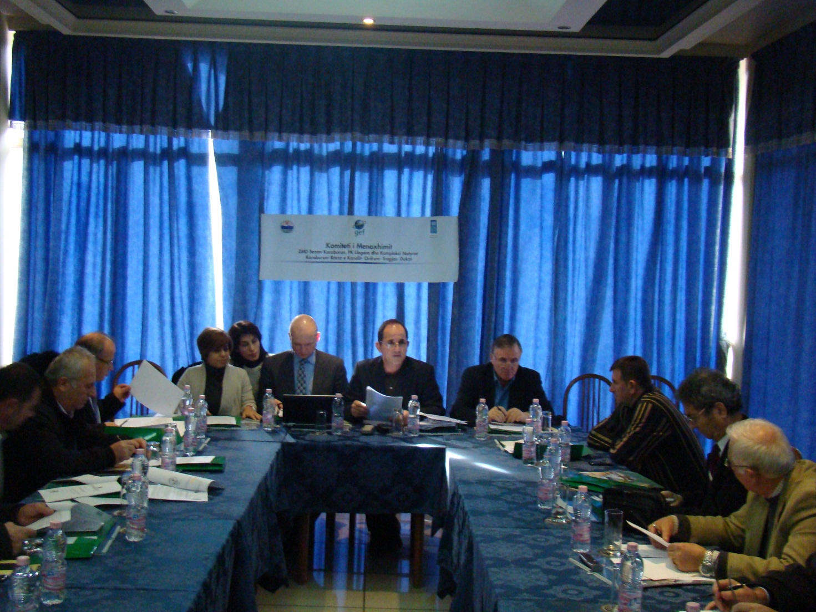
Based on the order of the Minister of Environment, Forestry and Water Administration (MEFWA), No. 6088, Date August 16,2012, on setting up the Management Committee (MC) of the “Marine National Park Karaburun-Sazan”, “National Park ’Llogara’’, “Natural complex ‘Karaburun-Rreza and Kanalit-Orikum-Tragjas-Dukat’’, it was held on December 17, 2012, at the premises of ‘Paradise’’ hotel, the first meeting of the Management Committee with the objective of constituting the Management Committee. Under circumstances that the greatest parts of Project board members are also members of the Management committee, a joint meeting of both organisms was organized.

Meeting’s objectives:

- Constituting of the MPA Management Committee based on Minister’s order No. 6088 Date 16.08.2012 ‘‘On the composition of the Management Committee of MPA K- S‘‘

- Informing the members of the Management Committee and Project Board on the activities carried by the Administration of the Forestry department in Vlora, the UNDP project progress, problems incurred so far and lessons learnt in course of activities implementation as well as the planned activities for 2013.

- Informing of the MPA Management Committee about the on going activities and decesion making issues.

Minutes and discussions are as in the following:

Presentation and opening of the meeting

The meeting was opened and was chaired by Z. Fatos BUNDO, representative of the MEFWA and director of the Biodiversity Department. In his greeting as the chairman of the Management Committee he thanked all the attending members for their participation and availability.

He made a short presentation on the first meeting of the Management Committee and project Board, as well as on its purposes and objectives. He asked each of the participants to make a short personal and institutional presentation. In the meantime, he noted with regret the absence of the representatives of Forestry Service Department in Vlore, which is under the jurisdiction of the MEFWA, and he said the participants that the Minister was going to be informed accordingly about that.

Afterwards Mr. Freddy Austli, UNDP Deputy Country direcor took the floor. After thanking the participants for their presence in the meeting, he highlighted the importance of the project implementation, the challenges it has to face, expectations and efforts for sustainable results for the good management of the protected areas in general , and of the marine PA Karaburun Sazan in particular. He especially thanked the Ministry for the fruitful cooperation in this aspect, but at the same time all other local actors thanks whose contribution the project work becomes more comprehensive and feasible.

Approval of the meeting agenda

Mr. Bundo invited all memebrs of the Management Committee to revise if necessary (provide any comment or suggestion) or to approve the agenda. All the members agreed on the agenda. (see Agenda in Annex 2).

Presentation of the project progress

Mr. Bundo invited Mrs. Violeta ZUNA, Project Manager to make a detailed project presentation and up to date achievements.

Mrs. ZUNA thanked all the board members, and informed them through a detailed summary of the work carried by the project, purpose and its main tasks, short term and long term objectives to be achieved by the project. She highlighted the long and difficult process of preparation and signatature of the Memorandums of Understanding with Orikumi Municipality and Forestry Service Department in Vlora, on the implementation of priority measures for law enforcement and control of illegal actions in the area (rangers contracting with the aim of patrolling the MPA K-S for preventing different illegal actions and protecting the values and assets of this marine national park); she also mentioned some of the main national and international expertizes which are in process and especially the process of marine strategy development. Referring to the inception phase, she highlighted the meeting dated July 15, 2011, in the meantime she mentioned several environmental activities (as: World Wetland Day), a photo exhibition with resources and special values of the marine and coastal ecosystems. Special mention was also made for the periodic meetings of the project office with Orikumi municipality and Forestry Service Department about the area management improvement.
She further on presented the work plan for 2013 underlining the main challenges as the ones for the development of the national strategy for marine biodiversity and action plan, technical and logistic assistance to the Forestry Service Department in Vlora and adminstration of the MPA Karaburun–Sazan (structure, strengthening of capacities, management proirity actions etc); coordination with actors and other interested organizations in marine area protection and its management improvement, improvement of information and knowledge dissemination, and awareness for the protection and good management of the marine areas, etc,.

Mr. Bundo, after the presentation of Mrs. Violeta Zuna, on behalf of the MEFAW thanked the project office for the work carried so far in spite of difficutlies encountered during that period. He emphasized again the importance of awareness of all local and national actors, as well as of public opinion about the importance of management and protection of marine and coastal habitats. To this end, the Ministry of Environment is in the process of preparing a publication promoting all the environmental values of the area which will be distributed as part of an awareness campaign.

Discussions and suggestions on the MPA K-S

Management board members had different opinions on the importance of this area as well as on various positive impacts the project imlpementation would have in that area.

Mr. Nihat DRAGOTI, Chief of the Protected Areas Section at MEFWA, informed and made some clarifications about the PA management plans which will of course be revised conform the requirements of the local governments. He expressed the concern of the Ministry about the absence of the Forestry Service department representative, because this institution is assigned to be leading all these activities in the area and is legally obliged to collaborate in the implementation of such activities. In the meantime he highlighted the maximum care that should be given to the protected areas thus reducing any potential threats.

Prof. Dr. Mynyr KONI, Dean of Science Faculty, member of the project board, after clearly expressing his support to such projects he congratulated the initiative, and asked the Management Committee to privode him with more detailed information, because the available infomation was not sufficient enough to have a clear picture of the project.

Mr. Niko DUMANI, representative of Vlora prefecture, greatly appreciated the initiatives focused on protection of environment, natural values and ecosystems. In the meantime he highlighted the importance of the MPA Karaburun – Sazan as an area with specific and vital values for Vlora. He offered his personal full commitment and also the availability of the prefecture which in cooperation with the Management Committee and project would organize various activities for promoting the environmental values. According to him, one of the greatest environmental hazards comes from urbanization, incited by a meeting of the district council on the regulatory plan which included Narta lagoon, which is another natural asset of the area. He had the opinion that there should be structures and mechanisms in place for estimating the urbanization impact level on environment, for preventing environment destruction. He suggested that the Department of Forestry service (which does not have a webpage) and Orikumi municipality should in the webpage provide sufficient information on the environment situation and any other information contributing to the prevention of illegal activities which damage the environment and the MPA K-S.

Mr. Nexhip HYSOLAKO as representative of the NGOs, after expressing his high opinion and support to the project implementation and also to other similar projects aiming at this area protection, asked the representatives of the Ministry to coordinate and revise the planning instruments aiming at avoidance of management plans duplications, thus making possible an efficient and effective development of the management plans (referring to the partial plans or the plans developed recently on pastures) with the ultimate aim of improving these areas management.

Mr. Mezan MEZANI, Chairman of the Fishing Association in Vlora, put the emphasis on the activities of the fishing associations as one the components which contribute in the Karaburun- Sazan area protection. Its activities are carried in full compliance with relevant laws, criteria and standards. He requested from the Ministry representatives to facilitate their activities but also asked for a greater involvement of the association in the project relevant activities. He also suggested that there should be publications containing lot of information on the marine protected areas which will define the borders, specific values and sectorial particularities of their management.

After after having heard the MC members’ views, Mr. Dragoti made some clarifications with reference to the raised issues, as in the following :

- He agreed with the request of Mr. Mezani about fishing development and the support which should be given to fishing associations. He stated that the MEFWA supports and should support in different forms Fishing Management Organization in Vlora thus enabling facilities for their activities.
- As for the buffer zone of the Marine National Park K -S he mentioned once again the attitute of the Ministry, that there would not be given licenses for any activity, even legal activity, as long as this activity impact in the PA is considered as considerable. This would contribute to the greatets protection possible of the area natural values.
- He explained the position of the Ministry on the request of Mr. Hysolakoj about buffer zone and its protection by mentioning the case of permits for fishing in this area, which are as dangerous although located outside the borders of the MPA.
- The coordination of the planning instruments, already completed or foreseen to be achieved, should contribute in the process of management plans development of MPA K-S, giving proper consideration to the requirements of the local governments in the respective areas.

Collaboration with Orikumi Municipality and Forestry Service Department in Vlora

The project, as reported by the project office has signed with these two institutions the Memorandums of Understanding. The respective representative reported in the meeting on the progress of work made so far, provided suggestions on various difficulties encountered in course of its implementaion.

Mr. Gezim CAPOJ, Orikumi mayor, made a detailed presentation of the work carried by this institution, as guard contracting for the MPA, making available to the local project office some premises in the municipality building. He also expressed the commitment of the municipality for close cooperation with the project because this serves the protection of the area and its values. He provided details on the up to date work of rangers which has given the first results in the work on law enforcement and MPA monitoring.
He mentioned the initial difficulties and expressed his belief that further on, due to the commitment of all parties, the area management will be more effective. One of his concerns was hunting of date shells (Lithophaga lithophaga = gurëshpuesi /dateri in ALb) in the MPA K-S, use of dynamite, as well as out of season hunting of wild boar and quails. He also mentioned the issue of the military buildings located in the area; actually these are no longer functional for military purposes so he asked the assistance of the ministry so that these assets to be used by the municipality through inventory transfer from the Ministry of Defense. He proposed one year contracting for the rangers for a more effective and complete coverage of the area. He offered his availability and the commitment of the institutuion he represents for collaboration not only with the Forest department, Vlore but also with all other actors who contribute in the improvement and effectiveness of the area management.

With reference to the project collaboration with the local institutions, Mr. Bundo stated that this is quite important and necessary for accomplishing the project objectives in the area. He highly appreciated the results reached so far as well as the contribution of each actor.

Mr.Doreid Petoshati, representative of the project local office presented to the Management Committe 5 logos/ ideas, submitted up to that time at the project office. These were designed by Zeqir Alizoti. While Mr. Eno Dodbiba, the project technical expert, presented the draft for the installation of informing labels in the area.

Mr. Bundo pointed out the need of the Marine National Park to have a logo /representation identity which will represent the park in all activities and will be used in all official documents. He stated in the meantime to all the members the idisputable impact of the improved visual information, and in particular putting of the informing tables in the MPA K-S area.

Mr. Dragoti with reference to the informing tables in the area said that this issue should be discussed in two aspects:
  - Discussions about the content of the main/presentation tables which should have these elements : a) easily seen by the visitors b) transmit a short information in two languages (Albanian and English); c) the material should be strong and resist time, environment and weather conditions; d) these should be put in safe places ensuring maintenace ;
  - Discussions on the informing tables need to be focused on their content, text, putting in different places because their tipology differs from that of main tables.

Mr.Dragoti suggested that about the logo a small group of experts should discuss clearly and define its elements. As the final deadline for the logo designs delivery is end December we need to wait till that time and make the evaluation of all proposals that will be submitted to the project office.

Prof. Dr. Mynyr KONI – Dean of Science Faculty, stated that the presented designs did not contain sufficient elements for the MPA K-S logo; the presented designs did not give a unique and prominent image. He shared the same opinin with the Mr Dragoti that there should be organized a meeting of experts for clearly defining the elements of the logo and that we wait for more representative and competitive designs to come till the deadline.

Subjects discussed by the MC and decesions

- Upon the constituion of the Management Committee (MC) the functions of the project board are transferred to this Committee;
- The management Committee endorsed the work plan for 2013 as well as the budget and respective activities;
- The informing tables be put in the two entry points of the Marine National Park;
- The official logo of the MPA Kaaburun-Sazan, to be determined at another stage, when all design proposals have been evaluated.

Closing of the meeting and conclusions
Mr. Bundo in the end invited all the participants in case of having any additional discussions or suggestions, then invited Mr Z. Austli, who in the end thanked once again all the participants and wished the Management committee good luck in its long work ahead. He once again highlighted that UNDP will continuously support the area, especially the Grants program which has started with the Orikumi municipality and Forest department taking into consideration their up to date performance. He also expressed his understanding of the practical difficulties in the project activities implementation, although these are quite well written on paper.

Thanking all the MC members for their participation and frutiful discusssions in the first meeting of the MC, Mr. Bundo closed the meeting wishing to see them all in the next subsequent MC meeting.

ANNEX I

List of participants

LIST OF PARTICIPANTS
Nr. | Name Surname | Position | Institution
1. | Freddy AUSTLI | Deputy director | UNDP Albania
2. | Fatos BUNDO | Biodiversity director | MEFWA
3. | Nihat DRAGOTI | Chief, PA sector | MEFWA
4. | Mynyr KONI | Dean | Faculty of Science
5. | Gezim CAPOJ | Chairman | Orikumi municipality
6. | Niko DUMANI | Environment expert | Prefecture Vlore
7. | Nexhip HYSOLAKOJ | Representative | NGO
8. | Ajen GRABOVA | Environment engineer | Vlora district
9. | Mezan MEZANI | Chairman | Fisherman Environmental Organization (OMP)
10. | Qezar MICI | Fishing inspector | Fishermen Association
11. | Arber ZARKA | Representative | Archeological park Amantia - Orikum
12. | Muharrem JAZOJ | Businessman | Private sector
13. | Violeta ZUNA | Project manager | MCPAs project
14. | Eno DODBIBA | Technical expert | MCPAs project
15. | Ema PACO | Finance Adminstratrative | MCPAs project
16. | Petrit DERVISHI | Local Moderator | MCPAs project
17. | Doreid PETOSHATI | Local facilitator | MCPAs project

ANNEX II

Agenda of the Management Board meeting
HOUR | ISSUE | PERSONI IN CHARGE
10:00  10: 15  10:30 | Opening of the meeting, greetings addressed to participants  Approval of the agenda  Constitution of the Management Committee of the National Park Llogara-Karaburun-Sazan | Fatos Bundo, Chairman of MC  UNDP representative  Fatos Bundo, Chairman of MC
10:45 | Presentation of the actual status of the national Park Llogara, Managed Natural Reservat Karaburun and marine park | Chief of the Park Management chief of the Forest Department
11:15 | Information on the UNDP project progress (genral information on achievements, main activities for 2013) | Violeta Zuna, Project manager
11:45 | Various issues | Participants
12:45 | Conclusin and closing of meeting | Fatos Bundo  Kryetar i KM
13:00 | Work ing lunch

